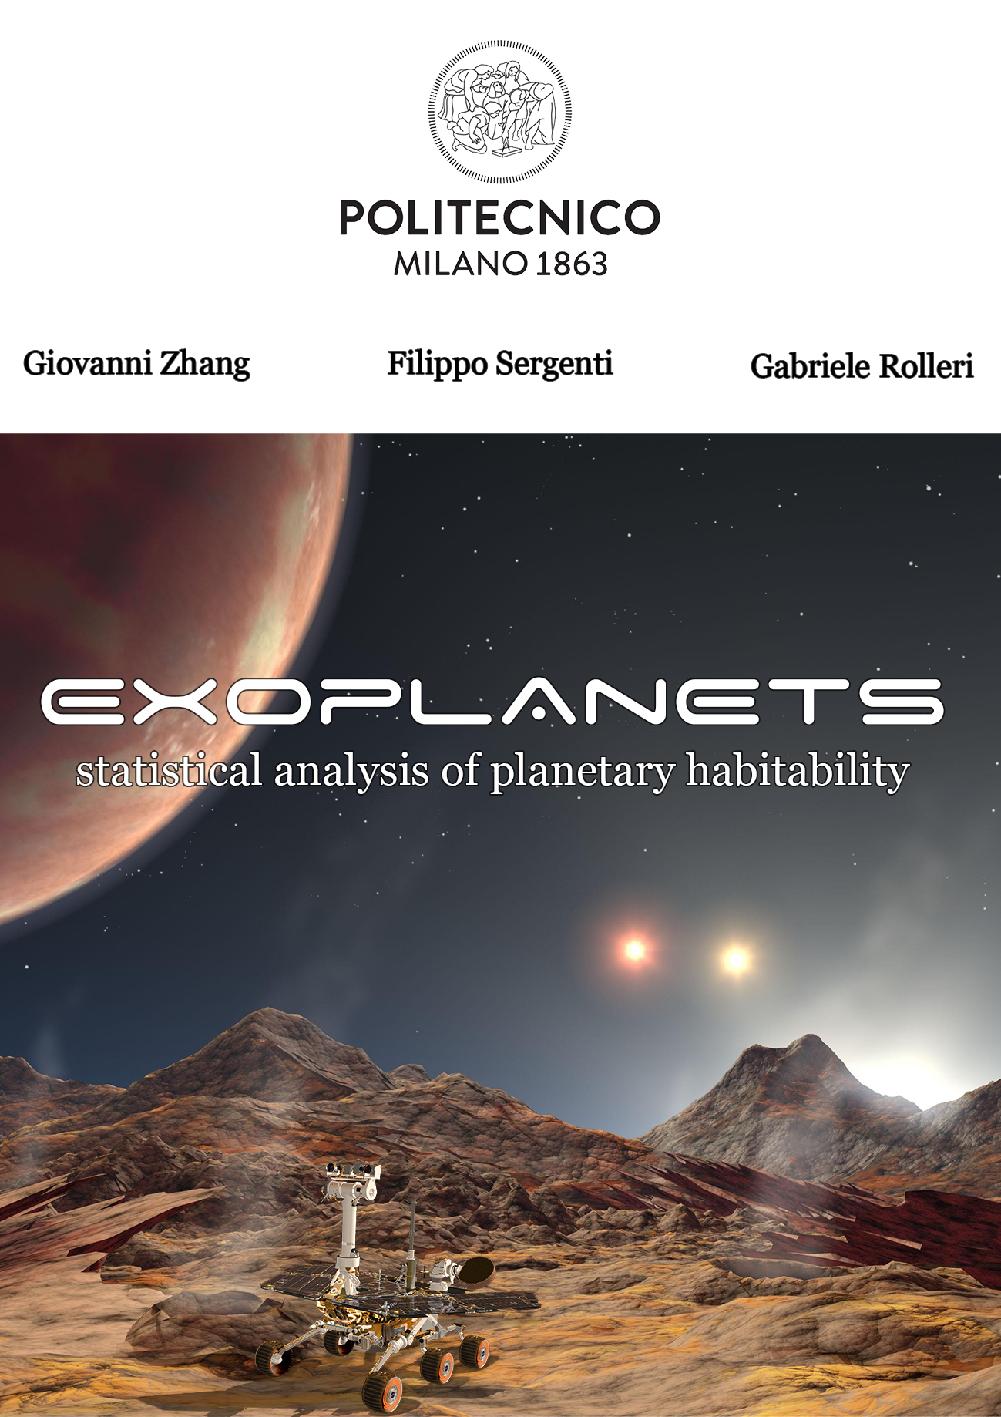

*“Two things fill the mind with ever new and increasing admiration and awe the more often and steadily we reflect upon them: the starry heavens above me and the moral law within me”*

***Immanuel Kant -* 1788 *- Critique of Practical Reason***

**Introduction**

We live in a golden age of exoplanet discovery and characterization.

Since its launch in 2009, the Kepler mission has discovered over 4,000 exoplanets, enabling detailed studies of their physical and orbital properties. In some cases, Kepler was even able to determine their compositions, thus providing important clues to the formation and evolution of planetary systems.

**Astrobiology & Cosmology**

Who are we? Where do we come from?

These are the questions that accompany us since our first steps on this earth.

The choice of this paper came not only from the fascination of these two questions but also from the possibility of addressing them in a rigorous and scientific way.

Obviously these are open questions and we think they will remain so for a few million more years, although a little discouraged, we try to aggregate all the available material on the subject validating it through the statistical tools learned.

**What’s an exoplanet anyway?**

An exoplanet is a planet not belonging to the solar system, that is: every planet orbiting around a star other than the Sun.

Fully confirmed only in 1995, the existence of exoplanets was for a long time considered more than plausible. The first hypothesis of the existence of these celestial bodies was formulated by Isaac Newton in 1713 in the "General Scholium" that concludes his Principia.

As of June 29th 2021, 4700 exoplanets are known in 3472 different planetary systems; 2487 is the number of candidate planets while 209 are still awaiting confirmation.

The discovery of exoplanets is made possible only by indirect observation methods.

Due to the limitations of current observational techniques, most of the planets detected are gas giants like Jupiter and, only to a lesser extent, massive rocky planets of the Super Earth type (2 to 10 Earth masses).

The thousands of exoplanets available for characterization allow us to conduct robust statistical studies. The sizes, masses, compositions, and orbital dynamics of these planets give us clues to their formation

**Index**

**Dataset 4**

**Descriptive Statistics 5**

Dataset Bias 5

Discovery Year & Method 6

Eccentricity 8

Mass 10

Orbital Period 11

Semi Major-Axis 11

Radius 12

Insolation Flux 13

Equilibrium Temperature 14

Stellar Parameters 15

Spatial Distribution 16

**Hypothesis Testing 17**

Normality Analysis 19

Number of Stars 20

Discovery Method 21

Rover Survival Temperature 23

**Multivariable Regression 25**

**Conclusions 30**

**Additional Resources 31**

**Dataset**

In this table are listed all the variables considered for our study.

In the following pages we will extensively treat each parameter, studying its statistical distribution, the scientific phenomenon behind it, how it is measured, and its importance in determining the habitability of a planet.

Data is freely accessible at the following webpage: [**exoplanetarchive.ipac.caltech.edu**](https://exoplanetarchive.ipac.caltech.edu/)

|  |  |
| --- | --- |
| **Planet Name** (pl_name) | Name of the planet most used in literature |
| **Number of Stars** (sy_snum) | Number of stars in planetary system |
| **Number of Planets** (sy_pnum) | Number of planets in planetary system |
| **Year of Discovery** (disc_year) | Year the planet was discovered |
| **Discovery Method** (discoverymethod) | Method by which the planet was first discovered |
| **Orbital Period** (pl_orbper) | Time taken by the planet to complete an orbit around the star or host system |
| **Orbit Semi-Major Axis** (pl_orbsmax) | The longest radius of an elliptical orbit |
| **Planet Radius** (pl_rade) | Segment that connects the center of the planet to its surface. Measured in units of the Earth's radius |
| **Planet Mass** (pl_bmasse) | Best available estimate of the planet mass |
| **Eccentricity** (pl_orbeccen) | Amount by which the planet's orbit deviates from a perfect circle |
| **Insolation Flux** (pl_insol) | Measure of the incident stellar radiation.  It is expressed in units relative to those measured for Earth. |
| **Equilibrium Temperature** (pl_eqt) | Temperature of the planet as modeled by a black body heated only by its host star |
| **Stellar Effective Temperature** (st_teff) | Temperature of the star modeled by a black body that emits the same total amount of electromagnetic radiation |
| **Stellar Radius** (st_rad) | Segment that connects the center of the star to its surface. |
| **Stellar Mass** (st_mass) | Amount of matter contained in the star, measured in units of the Sun's mass |
| **Right Ascension** (ra) | Right ascension of the planetary system, measured in decimal degrees |
| **Declination** (dec) | Declination of the planetary system, measured in decimal degrees |

**Part I: Descriptive Statistics**

We want to start with an exploratory analysis of the available dataset to deduce its general characteristics and trends.

**Dataset Bias**

Astronomers wonder why many large gas giant exoplanets are located very close to their star, compared to those in our solar system. For example, *T Bootis* has a planet four times the size of Jupiter at less than a quarter of the Earth-Sun distance. *HD 114762* has a planet eleven times the size of Jupiter, at less than half AU. One possible answer is that today's search methods favor the detection of these kinds of systems: a large planet placed at a small distance amplifies the star's oscillations, and they are easily detected by the Doppler effect. A smaller planet, at a greater distance, causes much smaller and harder-to-see oscillations.

Another explanation is that the planets formed at greater distances, and then moved inward due to each other's gravitational interactions. This model has been called **“the jumping Jupiters model”.**

As just said, most of the discoveries involve gas giants orbiting their stars at short distances. This type of planets, called **“hot Jupiters”**, greatly affect the radial velocity of their stars and frequently transit in front of them, facilitating their detection: due to selection effect there is a clear quantitative supremacy of such planets over the others. With the improvement of our tools & instruments the trend is reversing; it is therefore clear that the prevalence of Earth-like telluric bodies is higher than that of giant planets.

The fraction of smaller planets is constantly growing, especially thanks to the Kepler mission, which already allows us to define an outline of an exoplanetary classification based on size.

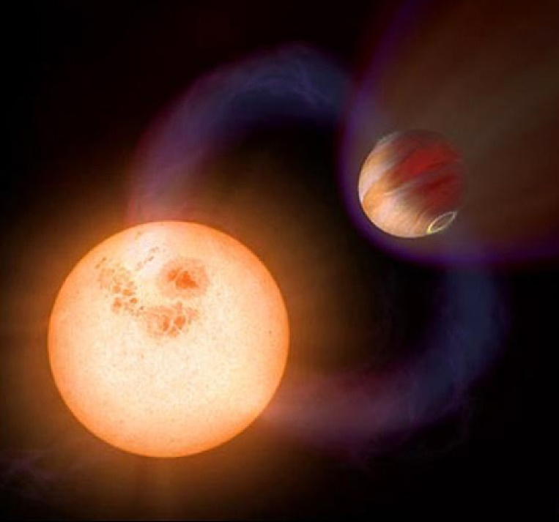

1. **Discovery Year**

Scientific interest in exoplanets has grown increasingly since 1992, the year of the first confirmed discovery (PSR B1257 + 12).

Initially the pace of discoveries was very slow, but since the 2000s it has experienced a real surge, going from 20 planets discovered in 2000, to 189 in 2011, to almost 3500 in 2016.

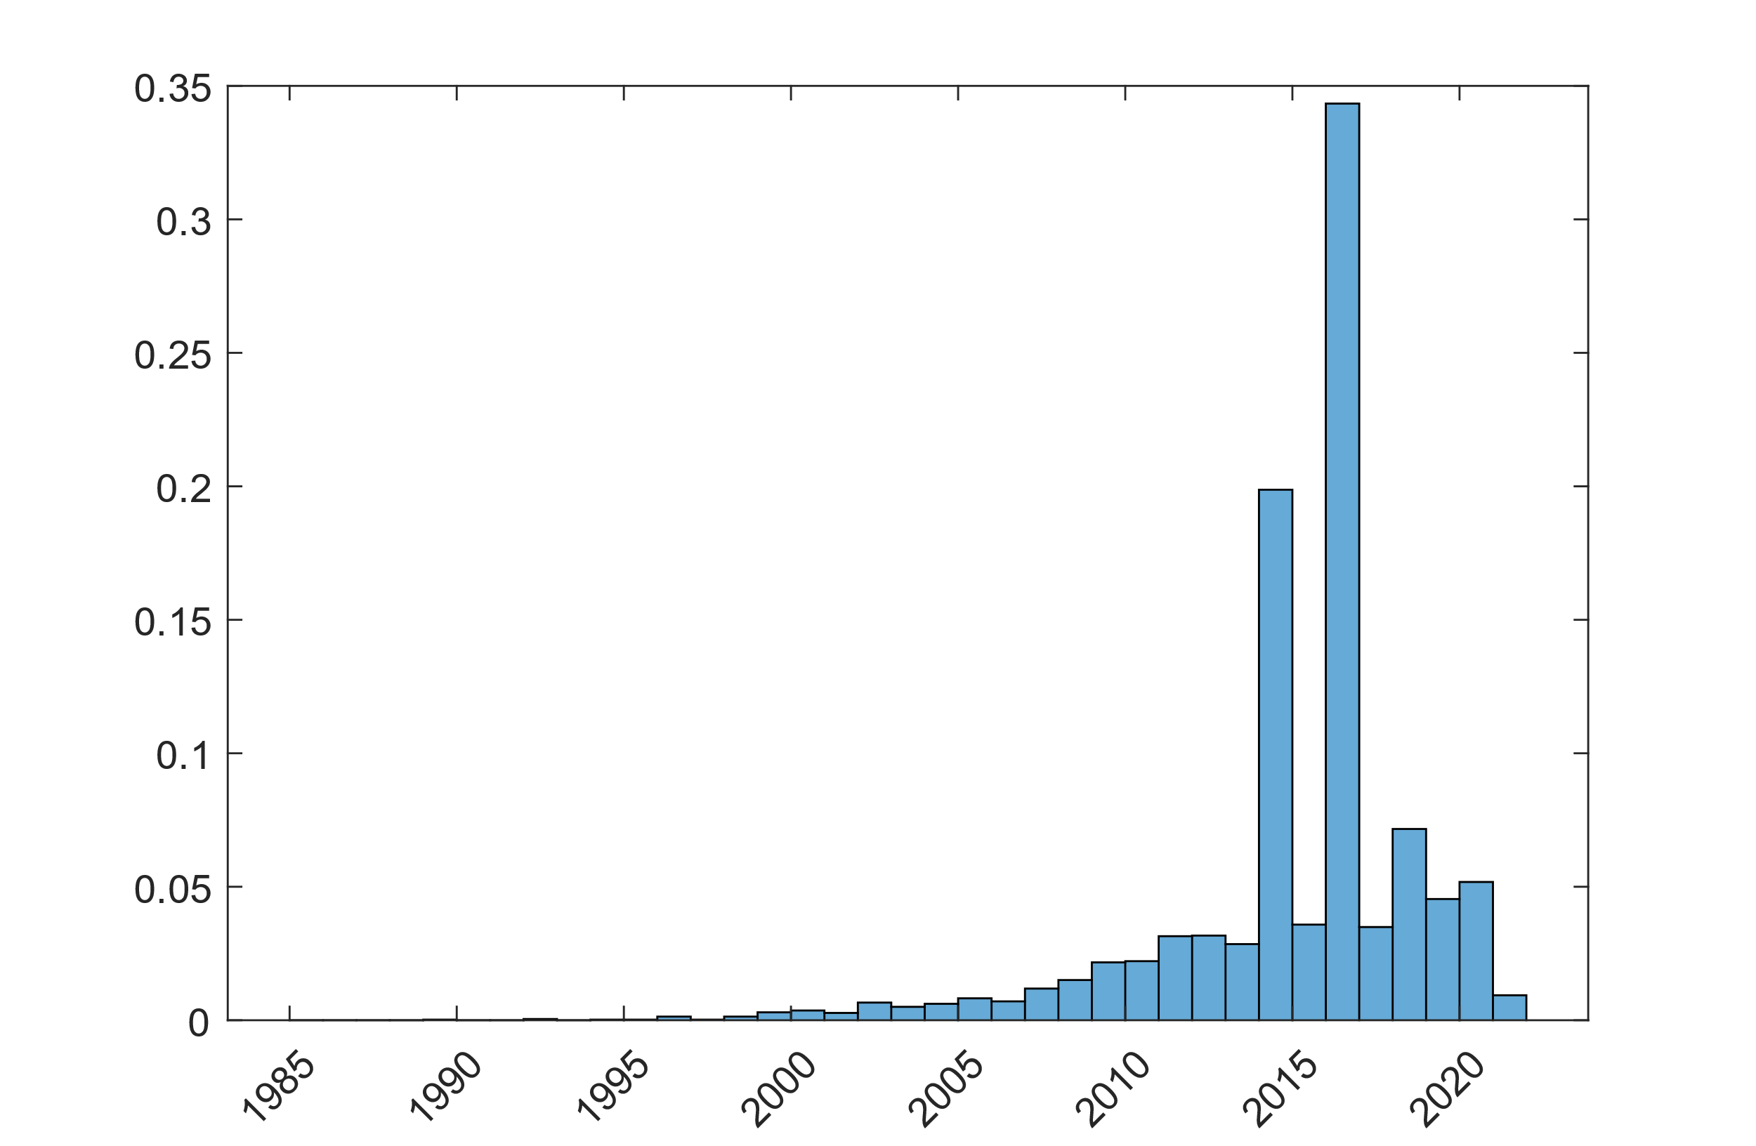

1. **Discovery Method**

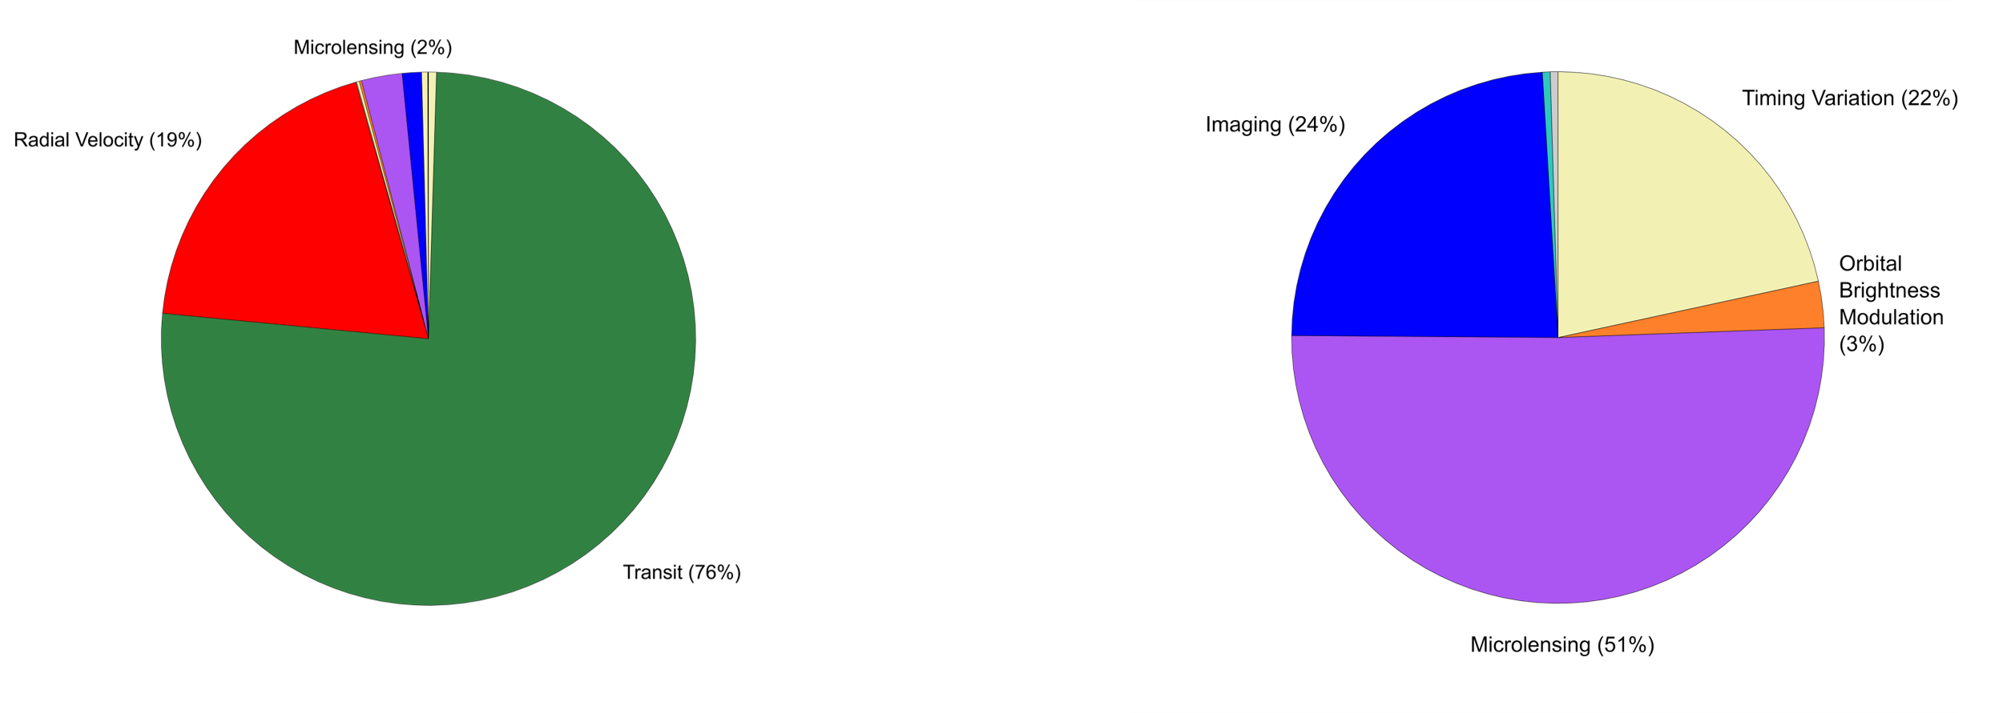

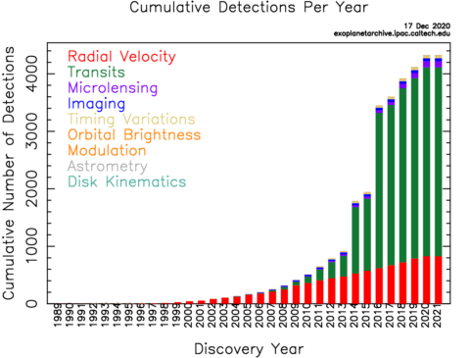

Discovery Method is a categorical variable that describes the process by which the planet was discovered.

Two methods are prevalent: Transit and Radial Velocity which together account for about 95% of the total.

Transit was a real revolution for the field of exoplanetology since it considerably increased the number of planets discovered per year.

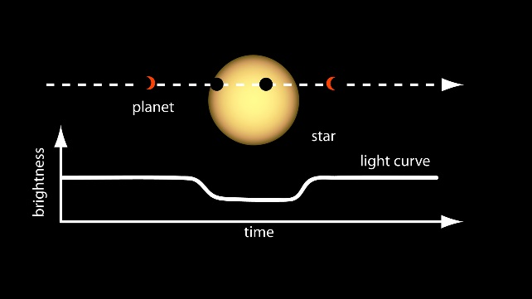**Transit**

Most recent and promising method.

A transit occurs when a planet passes between a star and its observer: a decrease in its brightness is recorded.

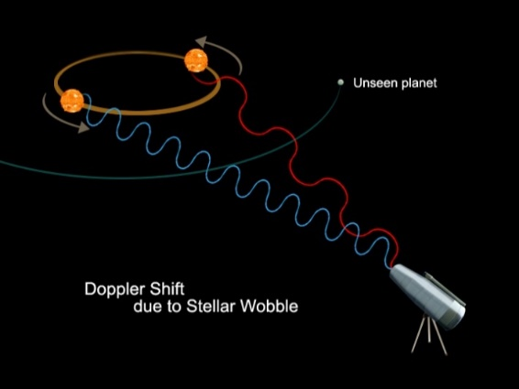**Radial Velocity**

Variations in the speed at which the star approaches or moves away from the Earth can lead to the deduction of the presence of a planet due to imbalances in the star's spectral line (Doppler effect).

This method is able to easily locate planets very close to their star, it does not work for planets with long orbital periods.

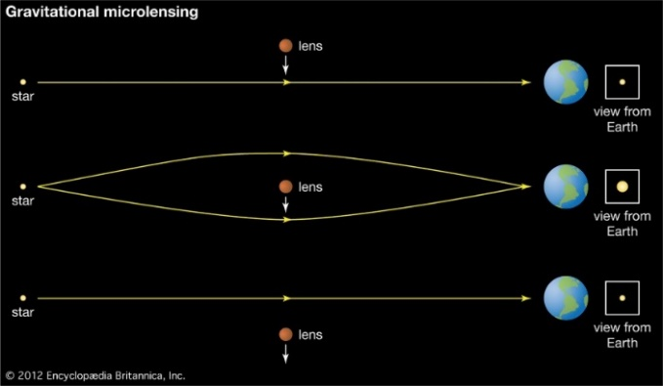**Microlensing**

Gravitational fields of two celestial bodies can cooperate to focus the light of a distant star. Perfect alignment happens very rarely and the effect is very small.

This method makes it possible to discover planets of comparable mass to that of Earth using the technologies available today

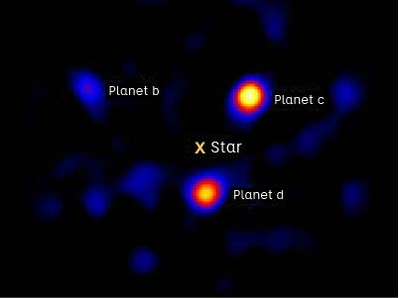**Direct Imaging**

Direct imaging uses infrared wavelengths to observe planets.

This method works for planets that are very far from their stars but does not allow astronomers to directly measure their mass. Spectrum and brightness can be used to obtain information on temperature and diameter.

1. 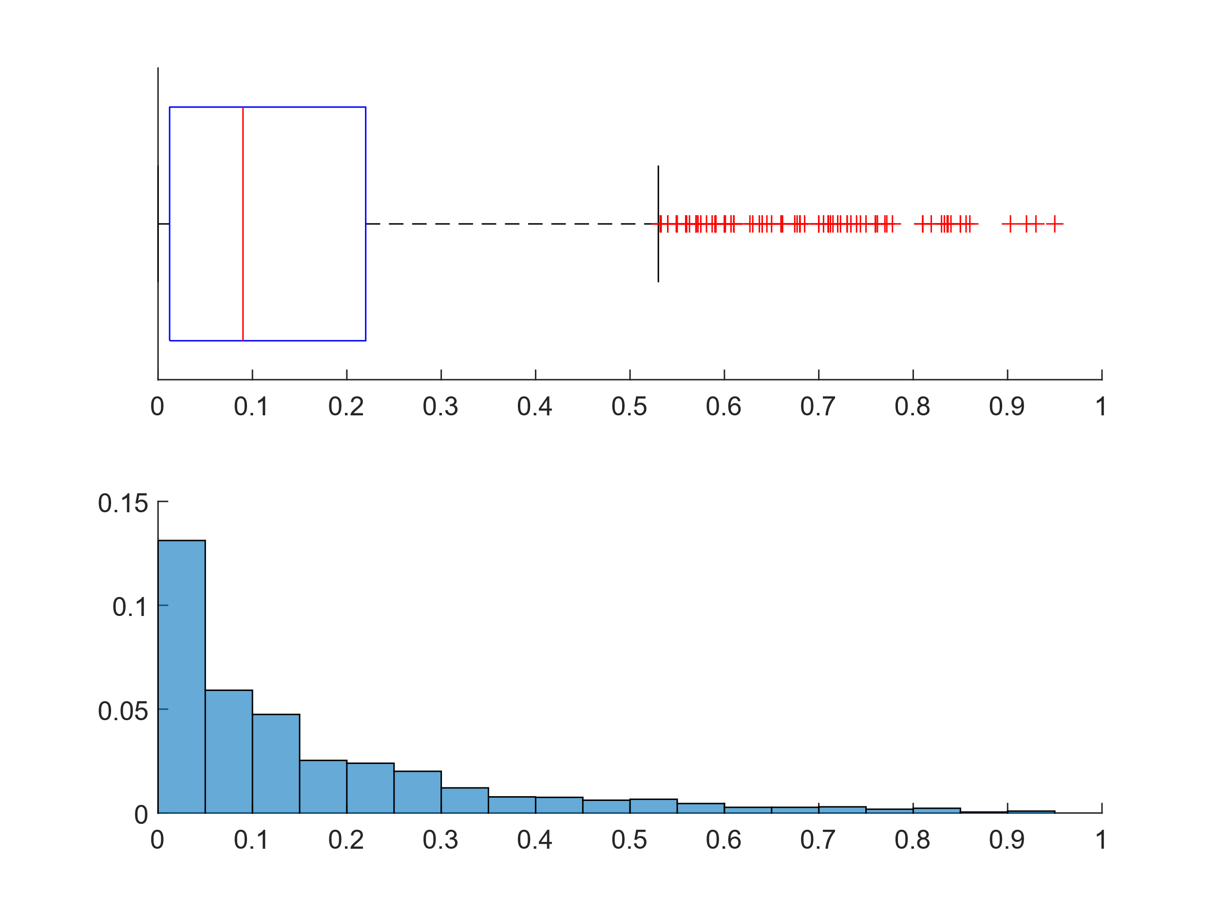**Eccentricity**

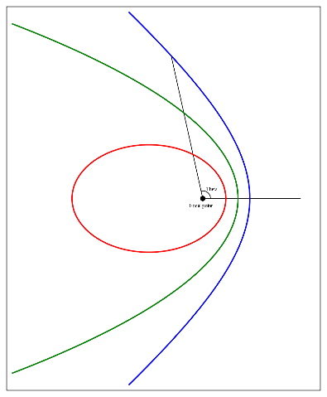

Dimensionless parameter that indicates how much the orbit deviates from a perfect circle.

A value of 0 indicates a circular orbit, values between 0 and 1 form an elliptical orbit, 1 is a parabolic escape orbit, if greater than 1 describes a hyperbole.

A planet with a stable orbit cannot have eccentricity greater than or equal to 1.

The Earth's orbit is almost circular, with eccentricity less than 0.02.

We can see how the distribution is strongly shifted to the left with a very long right whisker and a modest amount of outliers beyond that whisker, the median informs us that more than half of the planets have eccentricity <0.1, the histogram suggests that the sample may follow an exponential distribution, we then proceed to make a QQ-plot with respect to this distribution.

The center of the sample adheres very well to the line, while the high number of null values ​​creates a slight deviation in the left tail, the right tail also deviates from the line quite significantly. Ultimately, the distribution is not perfectly exponential but follows its characteristics.

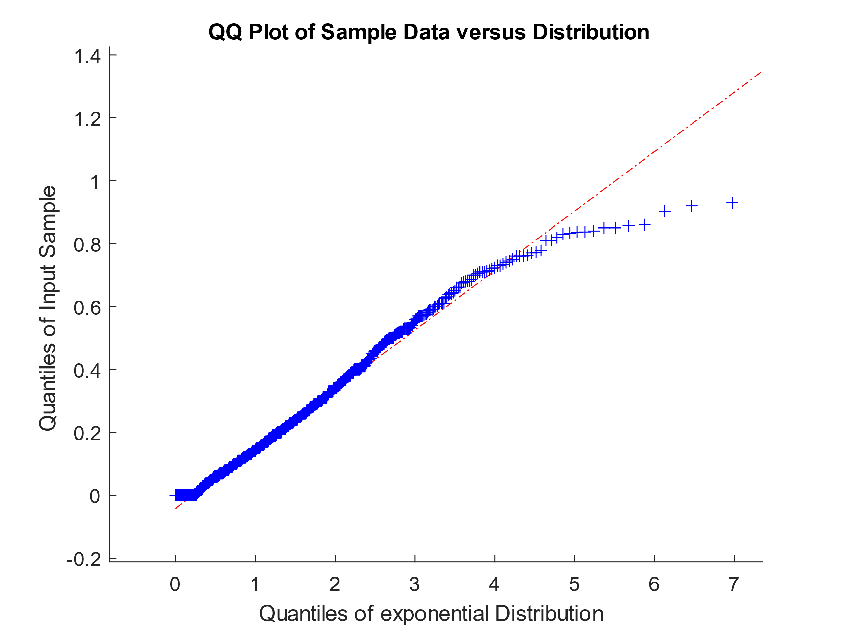

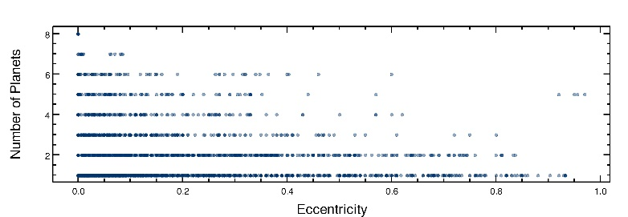

The data collected on the eccentricity of exoplanets surprised most researchers: 90% of the eccentricities are greater than those of the planets in the solar system.

These facts have been widely interpreted to indicate that the Solar System is an atypical member of the overall population of planetary systems.

Furthermore, orbital, and rotational stability is essential for the celestial body to be habitable. The greater the orbital eccentricity, the greater the temperature fluctuation on the planet's surface. It is essential that the planet has moderate seasons.

Equally the night-cycle must not be too long.

Despite adapting, living organisms are unable to withstand excessive variations in temperature, especially if they reach the boiling and freezing point of the planet's main biotic solvent (on Earth, water).

We report a strong anti-correlation of orbital eccentricity with multiplicity (number of planets in the system). If low eccentricities actually favor high multiplicities, habitability may be more common in systems with a larger number of planets.

These data could present a bias, in fact a big eccentricity increases the oscillation of the star and therefore facilitates the identification of the planet.

|  |  |  |  |  |  |  |
| --- | --- | --- | --- | --- | --- | --- |
| **Min** | **1st Qu.** | **Median** | **Mean** | **3rd Qu.** | **Max** | **NA’s** |
| 0.0000 | 0.0125 | 0.0900 | 0.1525 | 0.2200 | 0.9500 | 2780 |

1. 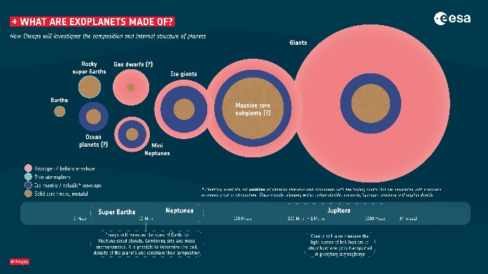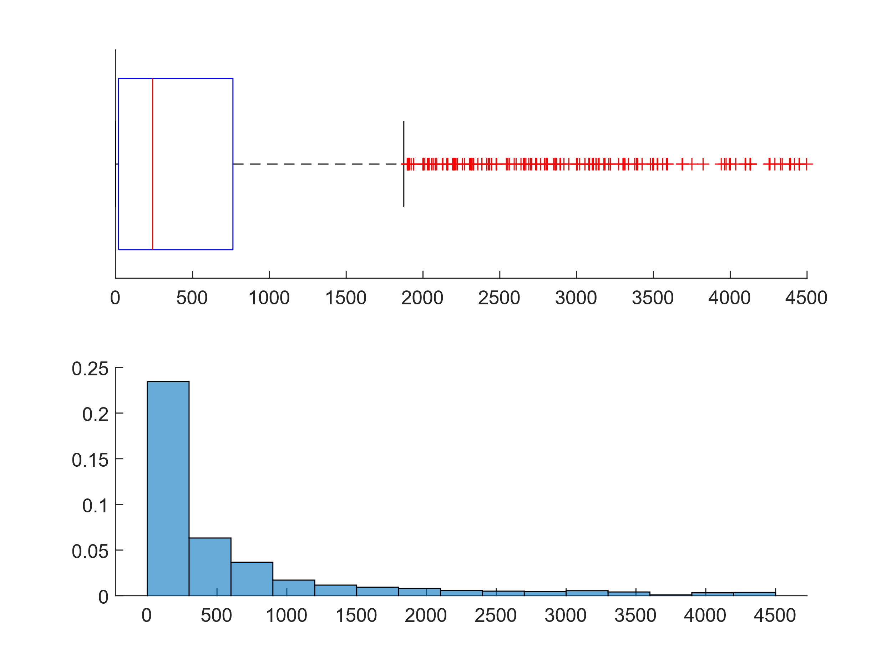 **Mass**

The distribution of the masses of the planets is very similar to that of eccentricities but with values even more flattened towards zero and a series of even more numerous right-hand outliers. The same tests carried out previously reveal again that the distribution is far from the exponential one. As for the eccentricity, we note that the mass entry-point is missing for a large part of our sample (57.5%, 2520 out of 4383)

Low-mass planets would be bad candidates for life for two reasons: First, their gravity would be lower and their atmosphere less dense. The molecules that make up life have a much higher probability of reaching escape velocity and being ejected into space by the propulsion of the solar wind or by a collision.

Planets whose atmosphere is not thick have less protection against high frequency radiation and meteorites, will not have enough matter for the initial biochemistry, are not thermally insulated enough, and have low thermal conductivity across their surface.

Furthermore, smaller planets have a smaller diameter and therefore greater surface-to-volume ratio than larger planets. Such bodies tend to lose energy much more rapidly after their formation and therefore have little geological activity. They do not have volcanoes, earthquakes or tectonic activity that provide the surface with elements favorable to life and the atmosphere with molecules capable of regulating the temperature (such as carbon dioxide).

Our Earth is large enough for its gravitational force to hold back its atmosphere and for its liquid core to continue to remain active and hot, thus generating geological activity on the surface (the disintegration of radioactive elements in the heart of the planet is another heat resource). Mars, on the other hand, is nearly inactive and has lost most of its atmosphere. Therefore, it is conceivable that the minimum mass of a planet that can be habitable lies between that of Mars and Earth.

|  |  |  |  |  |  |  |
| --- | --- | --- | --- | --- | --- | --- |
| **Min** | **1st Qu.** | **Median** | **Mean** | **3rd Qu.** | **Max** | **NA’s** |
| 0.02 | 18.30 | 240.00 | 744.13 | 762.79 | 17668.17 | 2520 |

1. **Orbital Period**

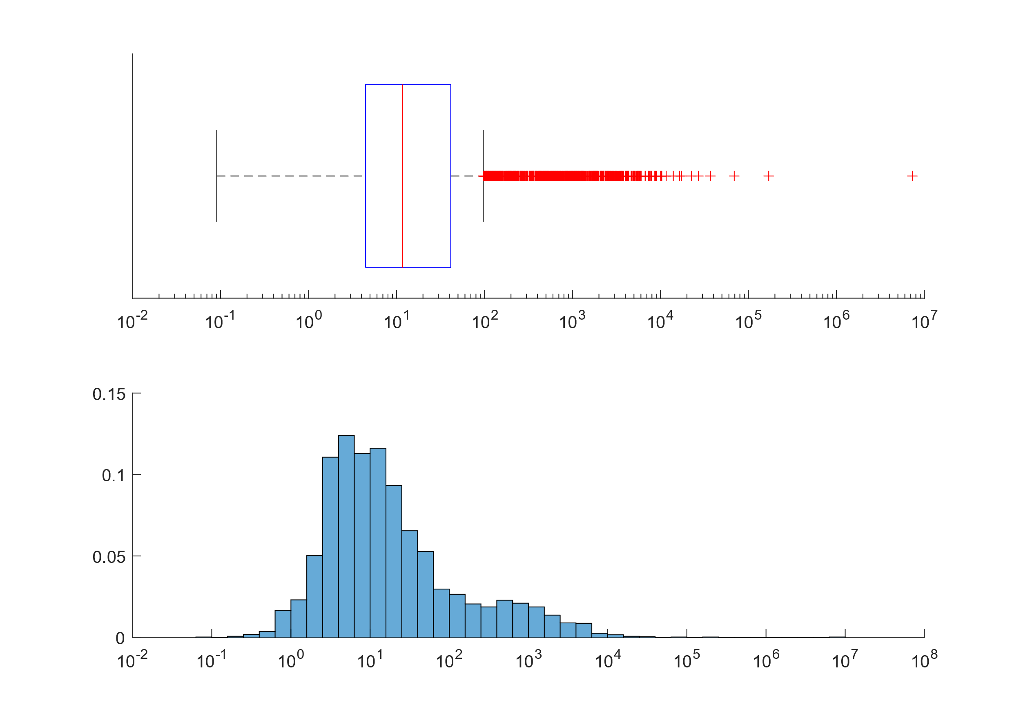

Given the huge range of data, which vary from less than one day to more than 7 million days, it was necessary to introduce a logarithmic scale, this obviously makes the information about the probability referring to the area of the bars unusable. In any case, the distribution has two maximums, one of which is clearly higher than the other, the second maximum includes most of the right-hand outliers. This high number of outliers and extreme outliers make the average roughly 200 times greater than the median.

|  |  |  |  |  |  |  |
| --- | --- | --- | --- | --- | --- | --- |
| **Min** | **1st Qu.** | **Median** | **Mean** | **3rd Qu.** | **Max** | **NA’s** |
| 0 | 4 | 12 | 2048 | 41 | 7300000 | 147 |

1. **Major Semi-Axis**

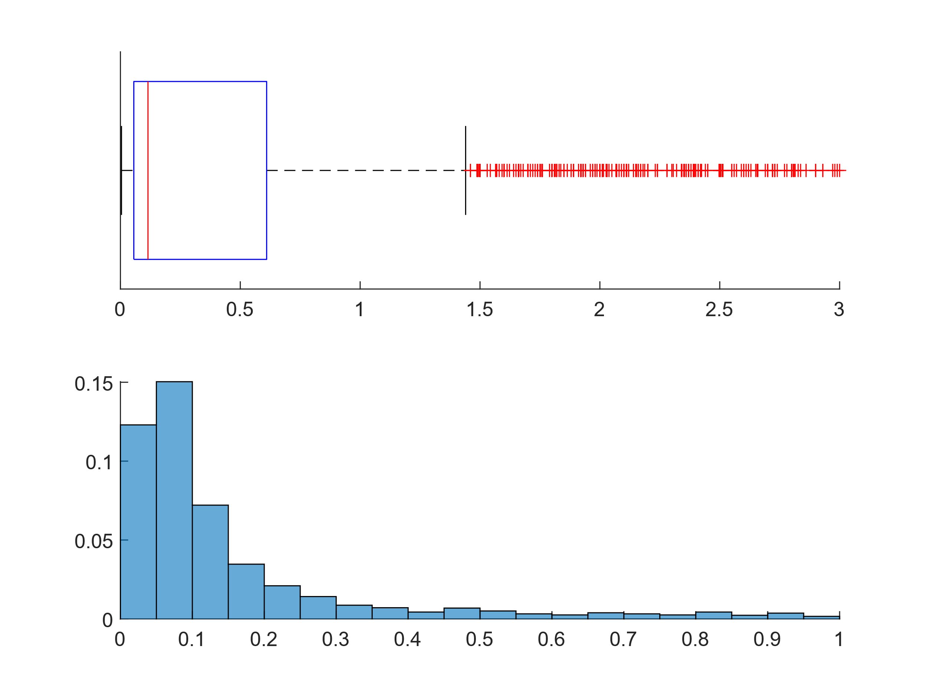

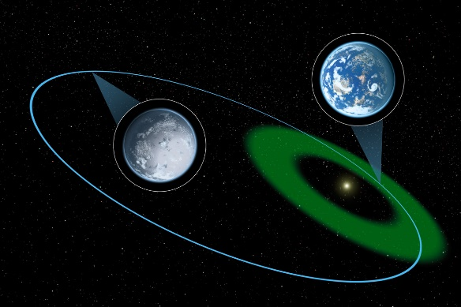

As the positions of the first and second quartiles suggest, the distribution of the semi-major axis is dense towards zero with a very long tail and extreme outliers thousands of times larger than the average.

|  |  |  |  |  |  |  |
| --- | --- | --- | --- | --- | --- | --- |
| **Min** | **1st Qu.** | **Median** | **Mean** | **3rd Qu.** | **Max** | **NA’s** |
| 0.004 | 0.056 | 0.115 | 8.620 | 0.608 | 3500.00 | 1749 |

1. **Radius**

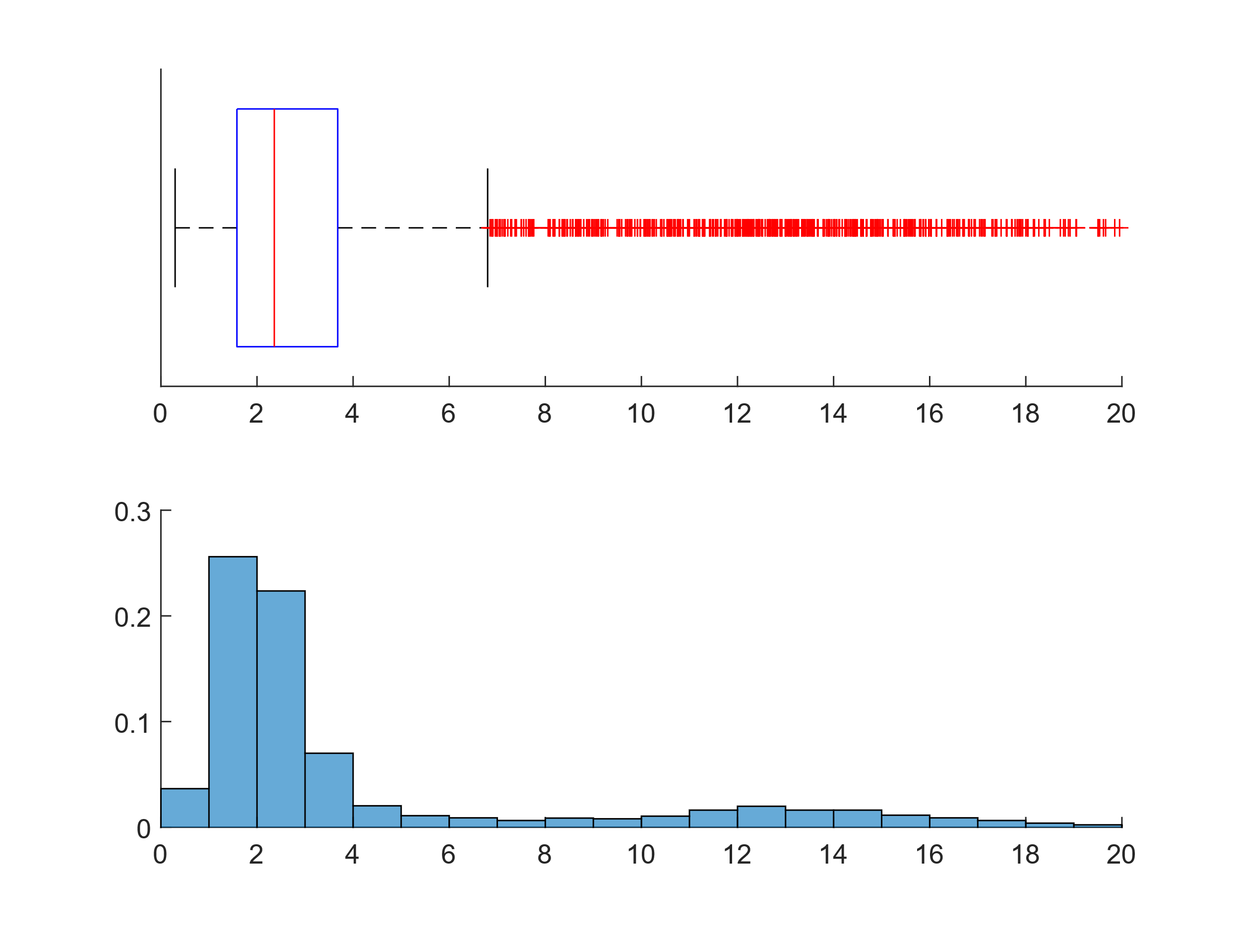

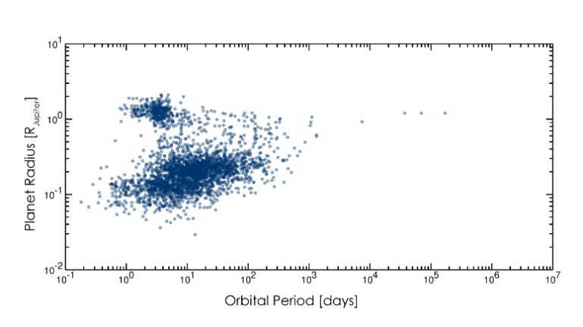

The “Fulton gap”, “photoevaporation valley”, or **“Sub Jovian Desert”** is an observed scarcity of planets with radii between 1.5 and 2 times the radius of the Earth.

This bimodality in the exoplanet population was first observed in 2013 and was noted as a possible confirmation of an emerging hypothesis that photoevaporation could drive atmospheric mass loss on nearby, low-mass planets.

This would lead to a population of bare rock cores with smaller radii at small separations from their parent stars and planets with thick envelopes dominated by hydrogen and helium with larger radii at greater separations.

The term **“photoevaporation”** refers to the process by which the atoms or molecules of a gas are torn away from an accumulation (a planet’s atmosphere, circumstellar disk, or nebula) by high-energy photons emitted by a star.

Despite the implication of the word "gap", this does not actually represent a radius range completely absent from the observed population of exoplanets, but rather a range that appears to be relatively rare. Consequently, 'valley' is often used in place of 'gap'.

|  |  |  |  |  |  |  |
| --- | --- | --- | --- | --- | --- | --- |
| **Min** | **1st Qu.** | **Median** | **Mean** | **3rd Qu.** | **Max** | **NA’s** |
| 0.296 | 1.585 | 2.360 | 4.287 | 3.680 | 77.342 | 1024 |

1. **Insolation Flux**

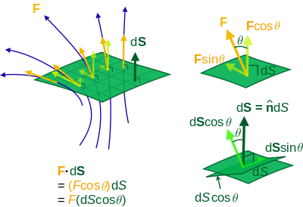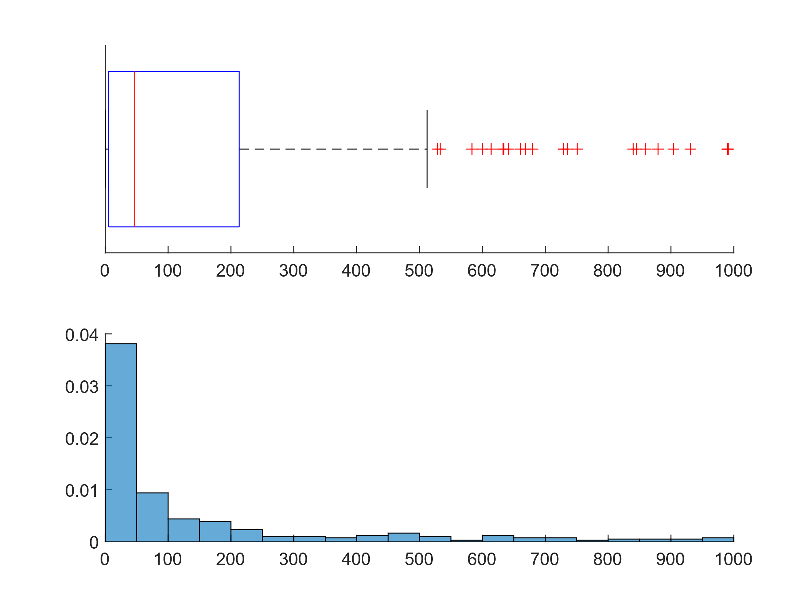

It is a measure of the total amount of electromagnetic radiation incident on the planet's surface calculated under the **black body hypothesis**.

Although the temperature is constant in the data reported, it is important to note that all stars have variations in brightness, the amplitude of these fluctuations is very different from one star to another.

Most of the stars are relatively stable, but a significant minority of them are variable and often have both drops and sudden increases in brightness. As a result, the amount of radiated energy that orbiting bodies receive undergoes abrupt changes. These stars are therefore bad candidates to host planets capable of allowing life as the strong variations in energy flux, (and thus temperature) have a negative impact on the survival of organisms.

For example, living things adapted to a particular temperature domain would likely have problems surviving major temperature changes. Furthermore, variations in brightness are generally accompanied by the emission of massive doses of gamma rays and X-rays, radiation that could be lethal.

The atmosphere of the planets is able to attenuate such effects (a 100% increase in stellar brightness does not necessarily imply a 100% increase in the planet's temperature), but it is equally possible that such planets will not be able to hold their own atmosphere because the strong incident radiations could disperse it.

The Sun does not have this type of variation: during the solar cycle the difference between the minimum and maximum brightness is around 0.1%

The distribution is noticeably skewed with tail very pronounced to the right, confirming this is also the fact that the mean is larger than the median. In the whole dataset, it is the parameter with the least number of entries (92.5% missing).

|  |  |  |  |  |  |  |
| --- | --- | --- | --- | --- | --- | --- |
| **Min** | **1st Qu.** | **Median** | **Mean** | **3rd Qu.** | **Max** | **NA’s** |
| 0.06 | 5.40 | 46.00 | 428.19 | 213.00 | 44900.00 | 4054 |

1. **Equilibrium Temperature**

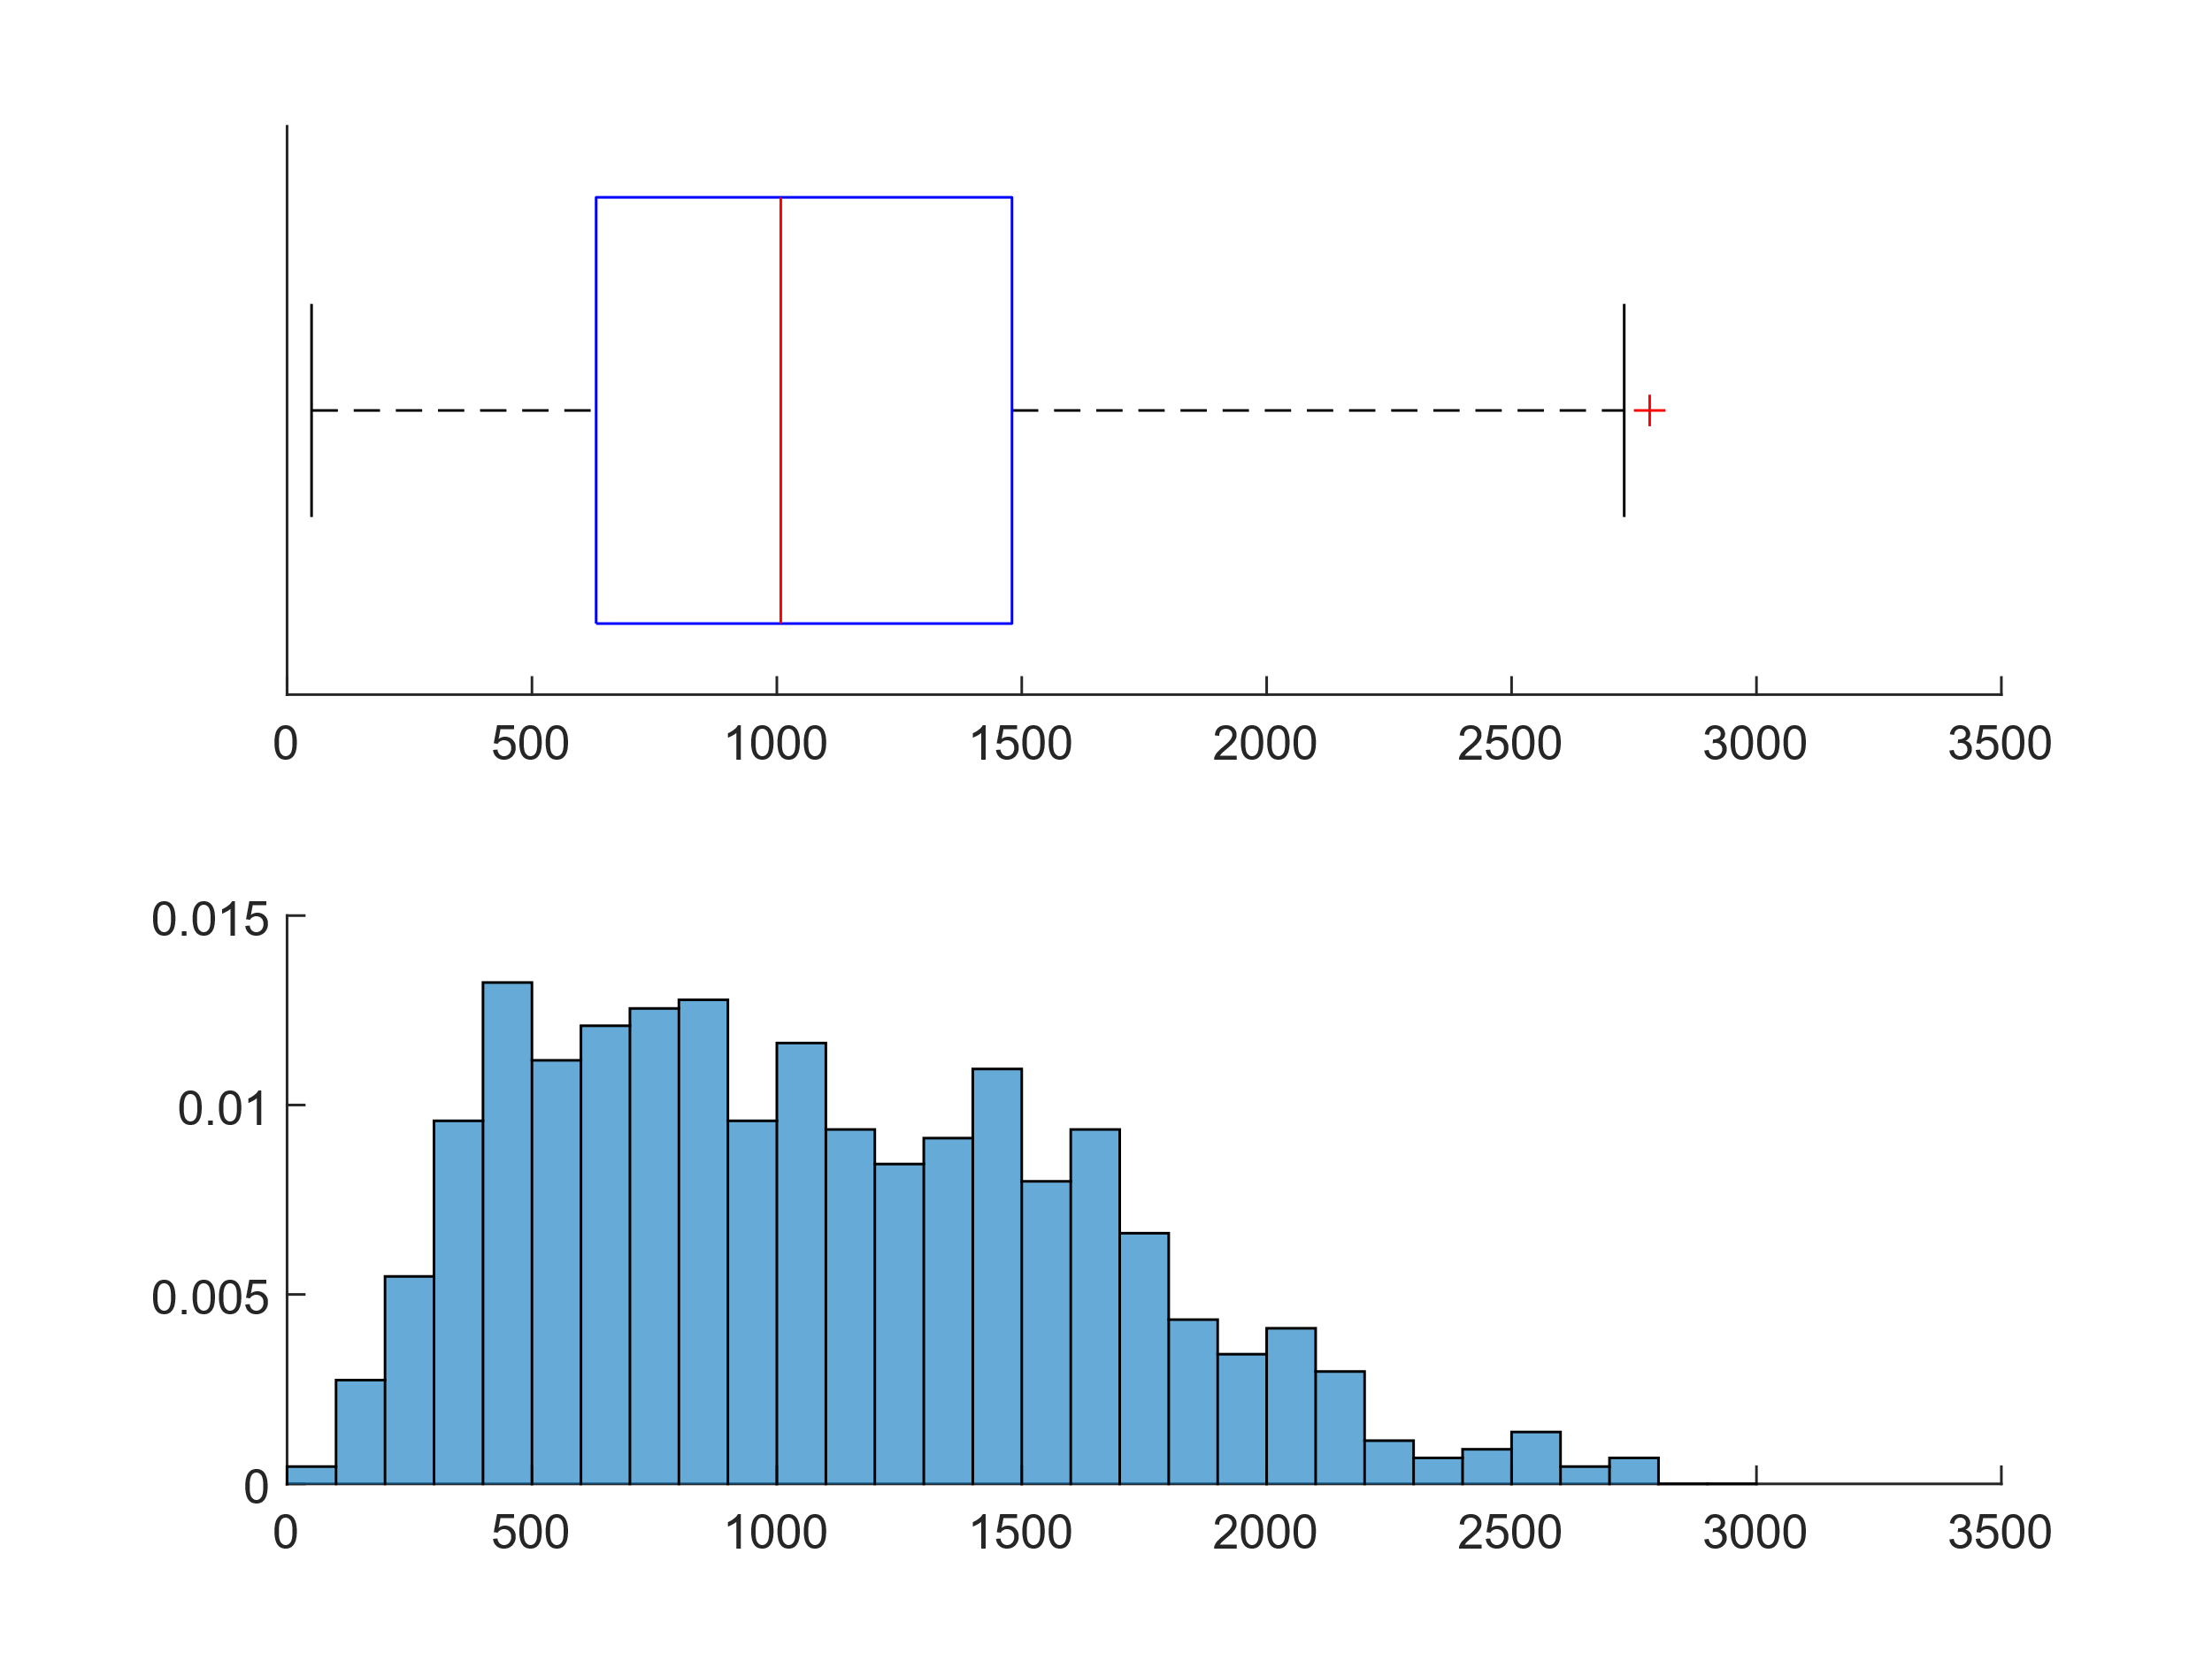

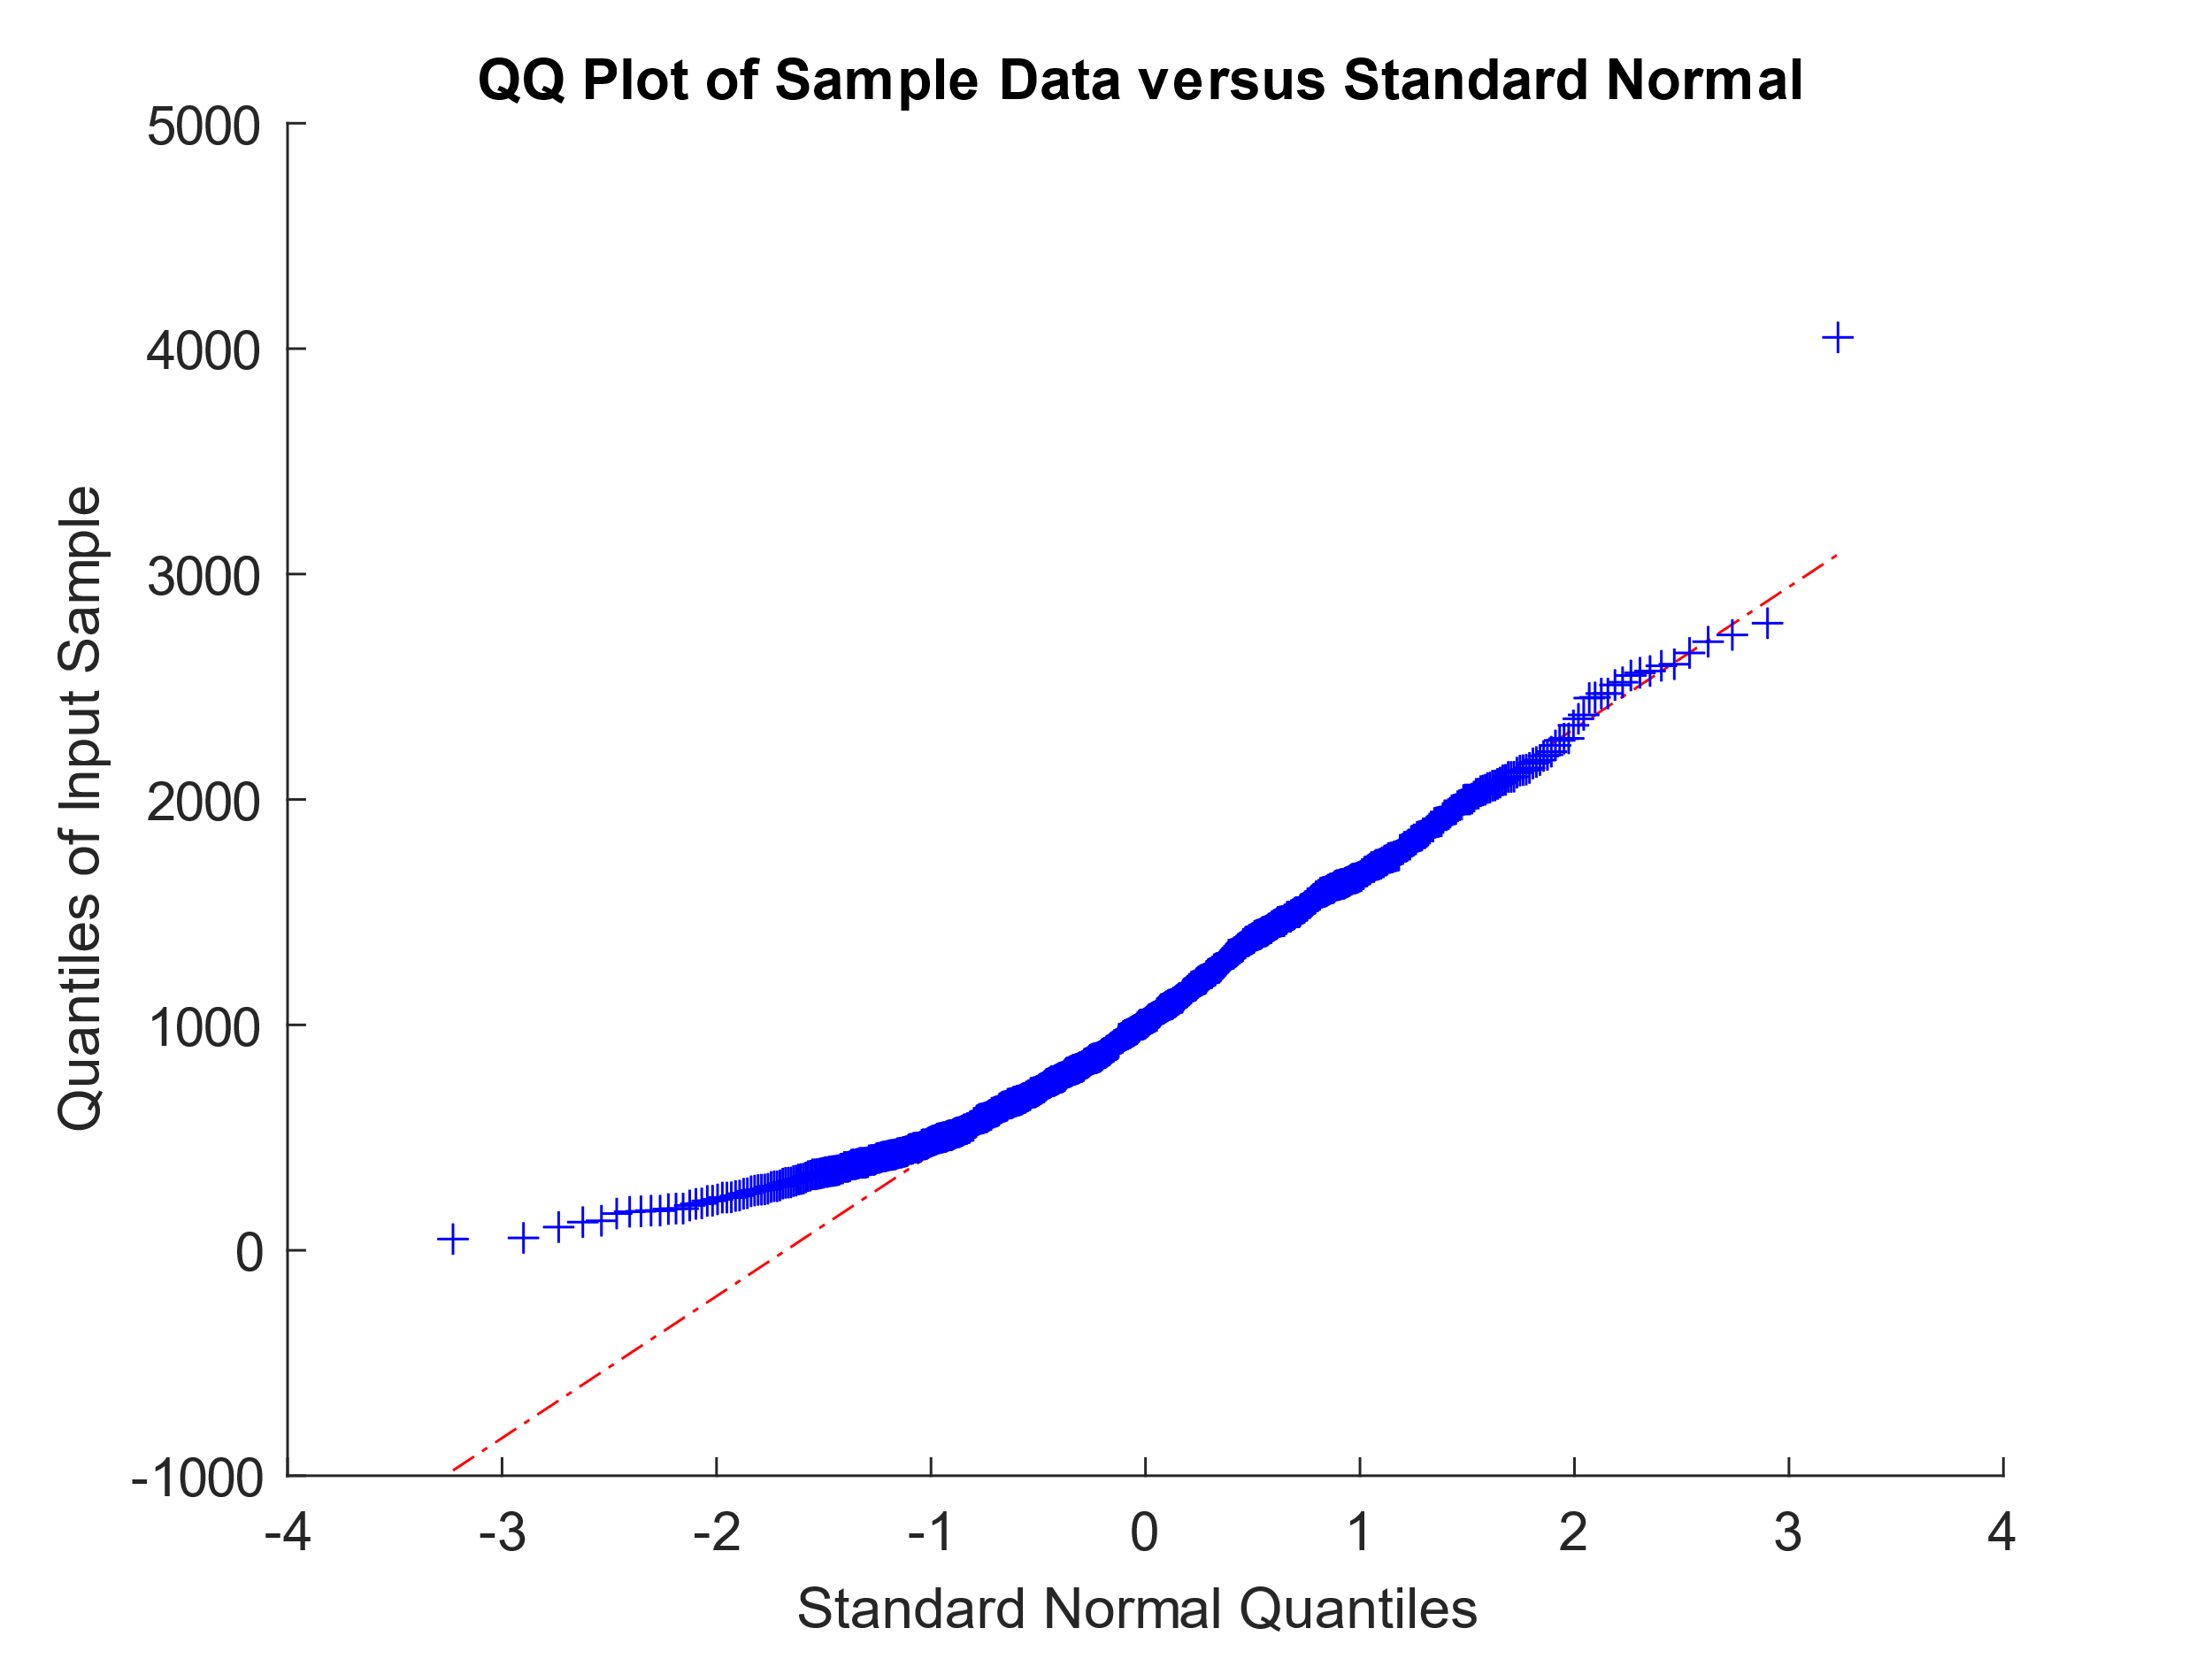

The planetary equilibrium temperature is the theoretical temperature that a planet would reach if it were a **black body**, heated only by its own star.

In this model, the presence of an atmosphere (and therefore a possible greenhouse effect) is not considered and the calculated temperature is attributed to an idealized surface of the planet.

It is the most similarly Gaussian distribution on our dataset, the average, being more sensitive to the data on the extremes, is slightly greater than the median, which justifies the hint of a tail on the right.

The planet's surface temperature plays a crucial role in the search for habitable exoplanets.

Unfortunately, there are currently no direct measurements available. Many physical processes affect a planet's surface temperature distribution. However, the dominant influence is an energy balance between the stellar radiation input and the radiative surface heat loss. With the further assumptions of a uniform planetary surface temperature, no filtering of incoming radiation and black body emission, the only variables are the stellar brightness and the exoplanet's radial distance from the star.

Analysis of some exoplanets also revealed the presence of very fast winds on the surface with peaks of 14,000 km / h. These winds keep the temperature of these planets constant over the entire surface with very small temperature variations.

|  |  |  |  |  |  |  |
| --- | --- | --- | --- | --- | --- | --- |
| **Min** | **1st Qu.** | **Median** | **Mean** | **3rd Qu.** | **Max** | **NA’s** |
| 50 | 631 | 1008 | 1082 | 1480 | 0.4050 | 3579 |

1. **Spatial Distribution**

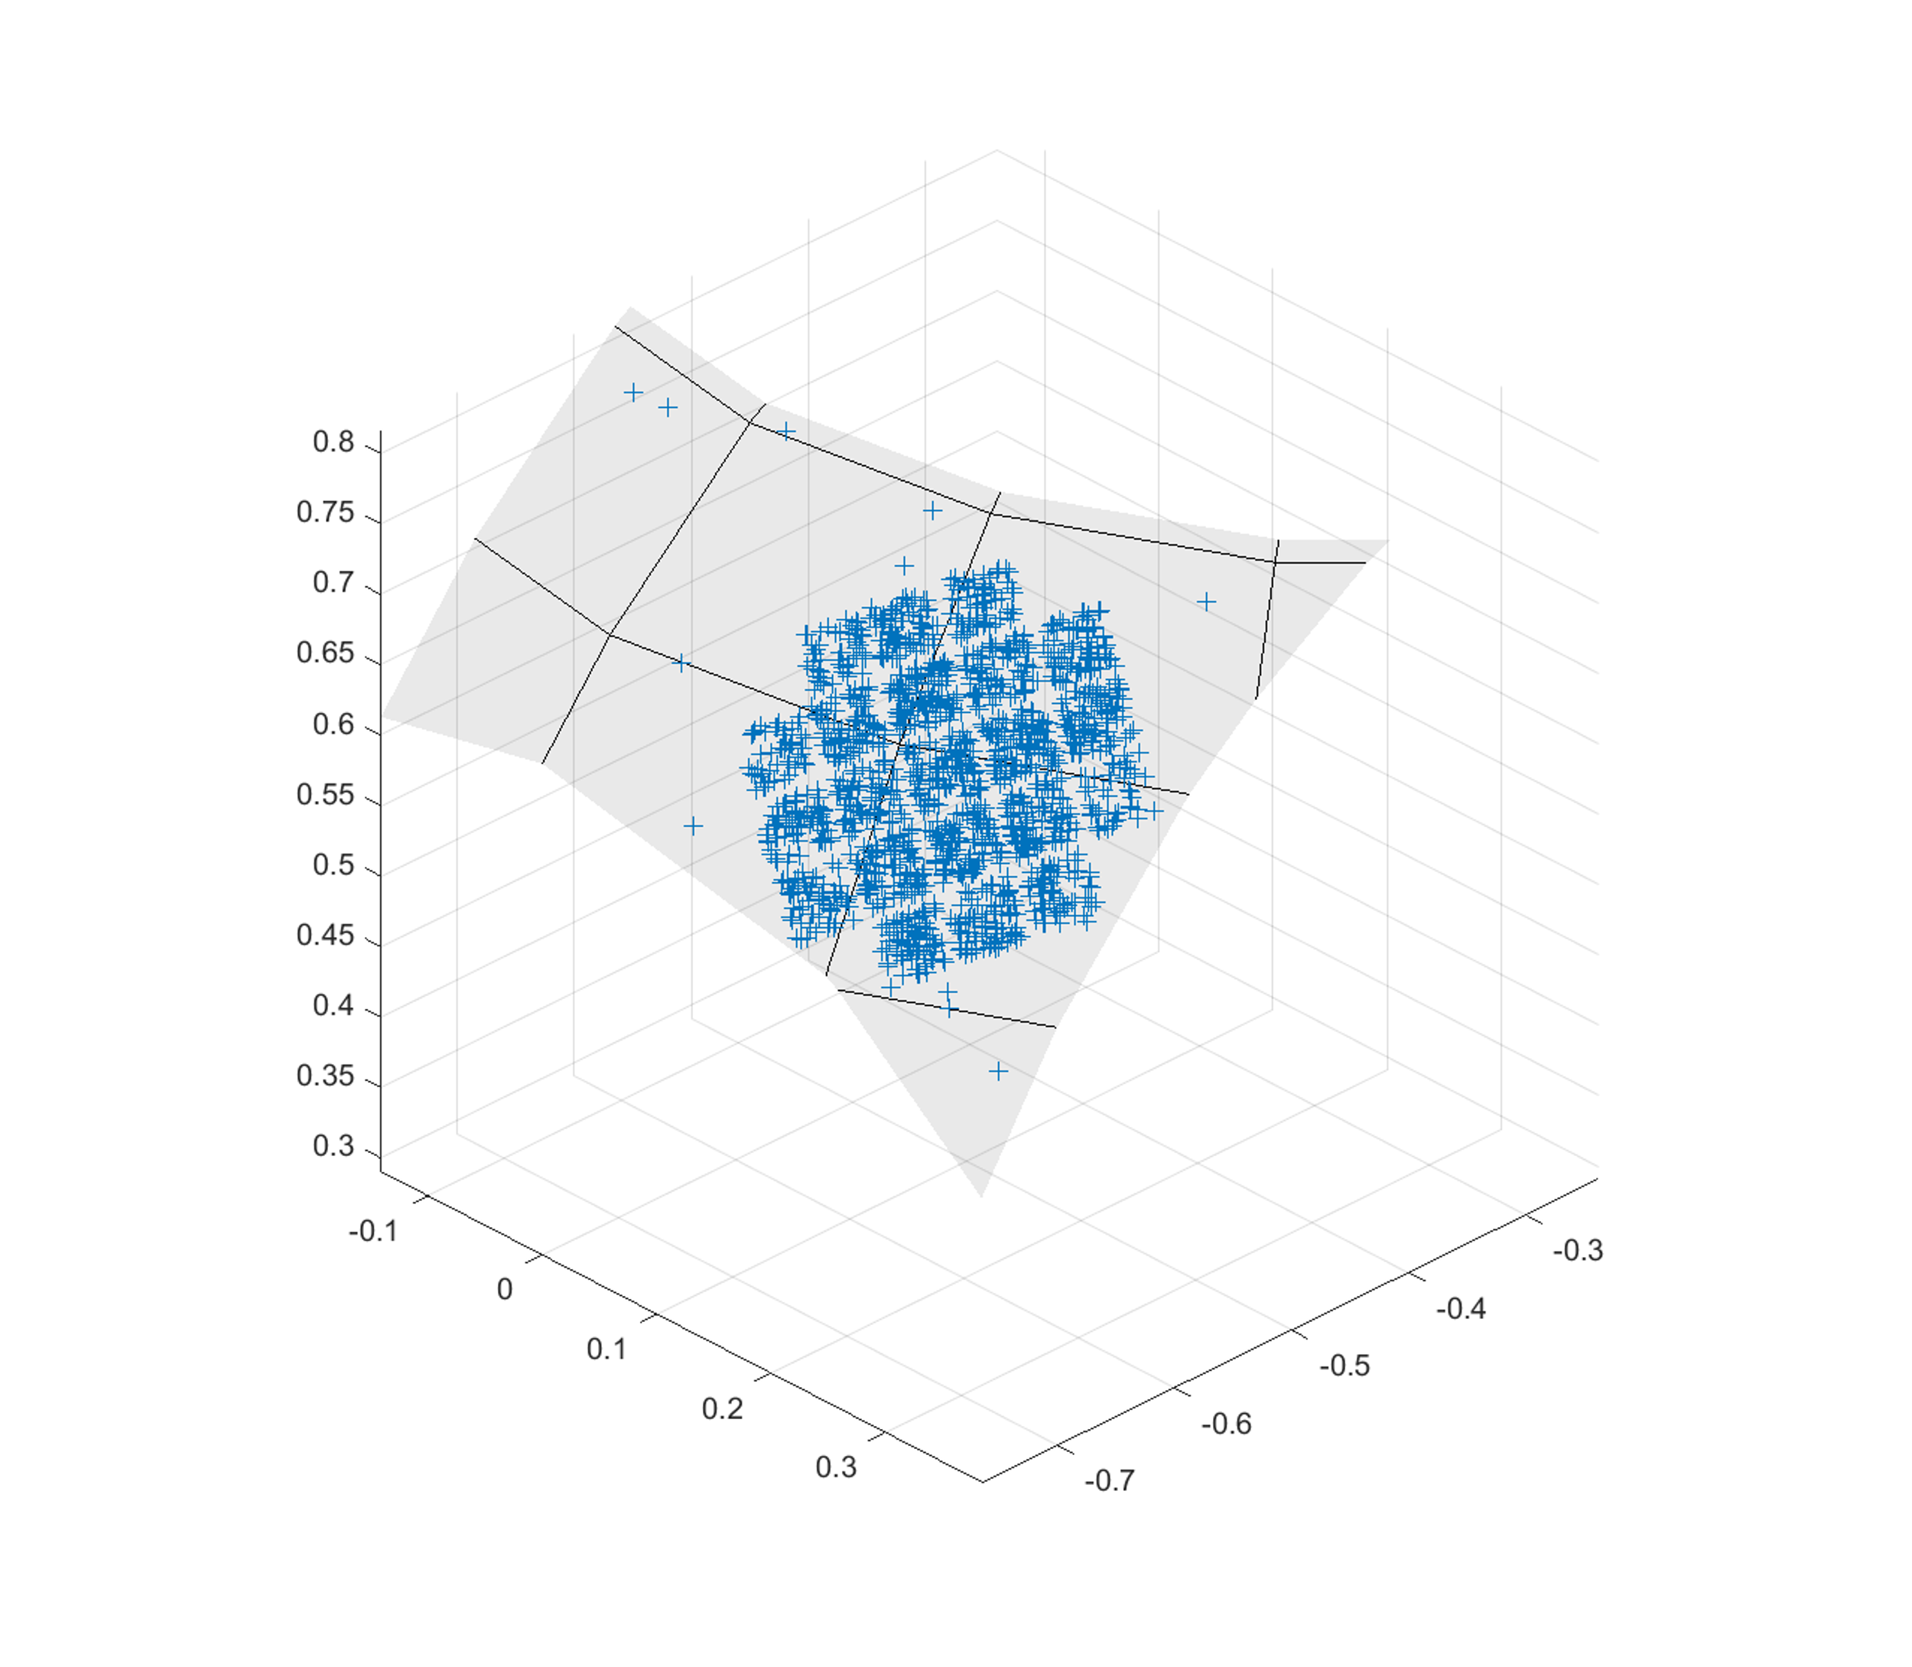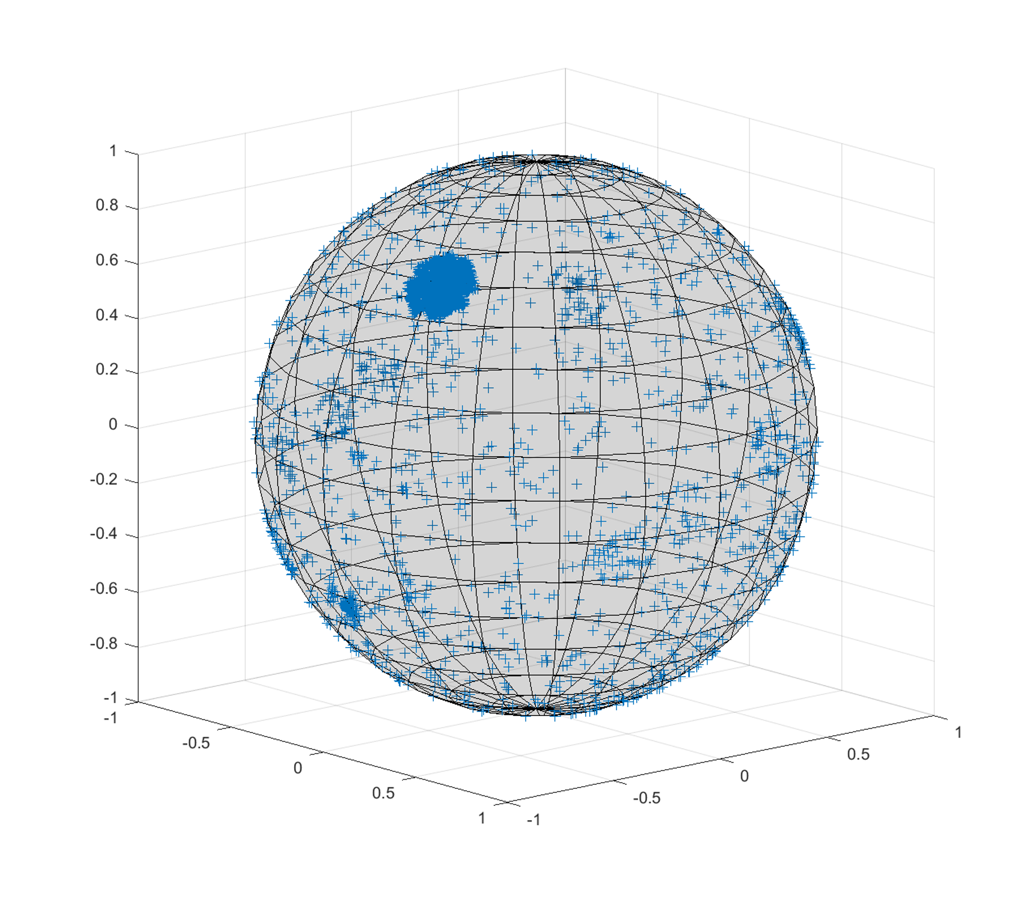

The distribution of exoplanets respect to the earth is quite random. However, there is a very marked bias in the dataset. The pattern visible in the first figure is not accidental: it represents the photometer of the Kepler Space Telescope.

**The Kepler Space Telescope** was specifically designed to monitor a portion of the Milky Way region to find out how many of the billions of stars in our galaxy could potentially host habitable planets.

To do this, a photometer constantly monitors the brightness of more than 145,000 main sequence stars in its fixed field of view, near the constellations of Cygnus, Lyra, and Dragon.

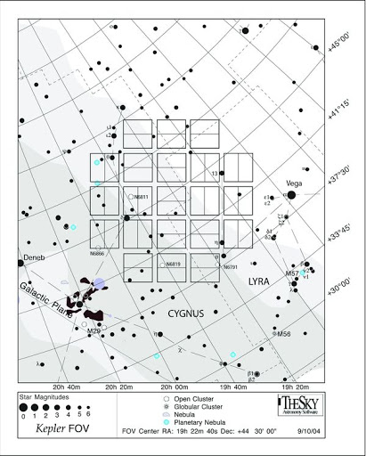

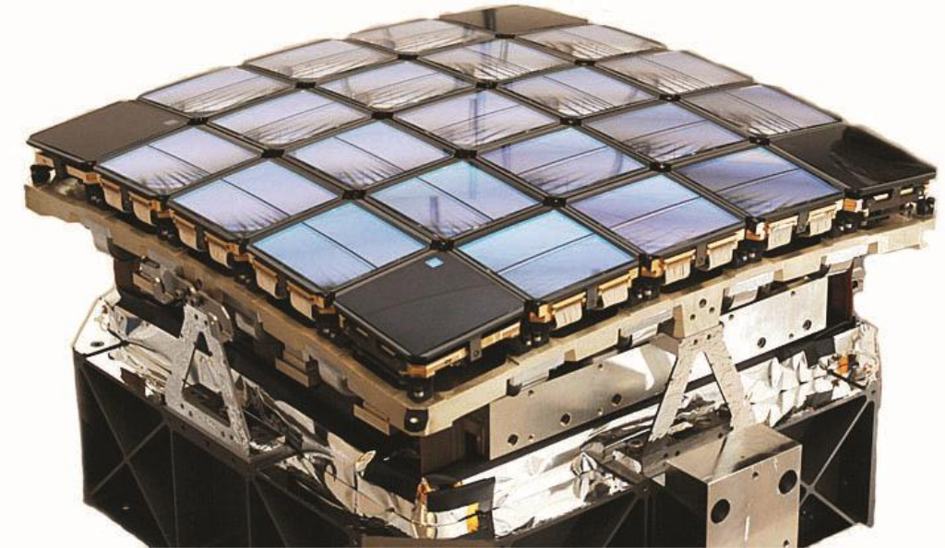

1. **Stellar Parameters**

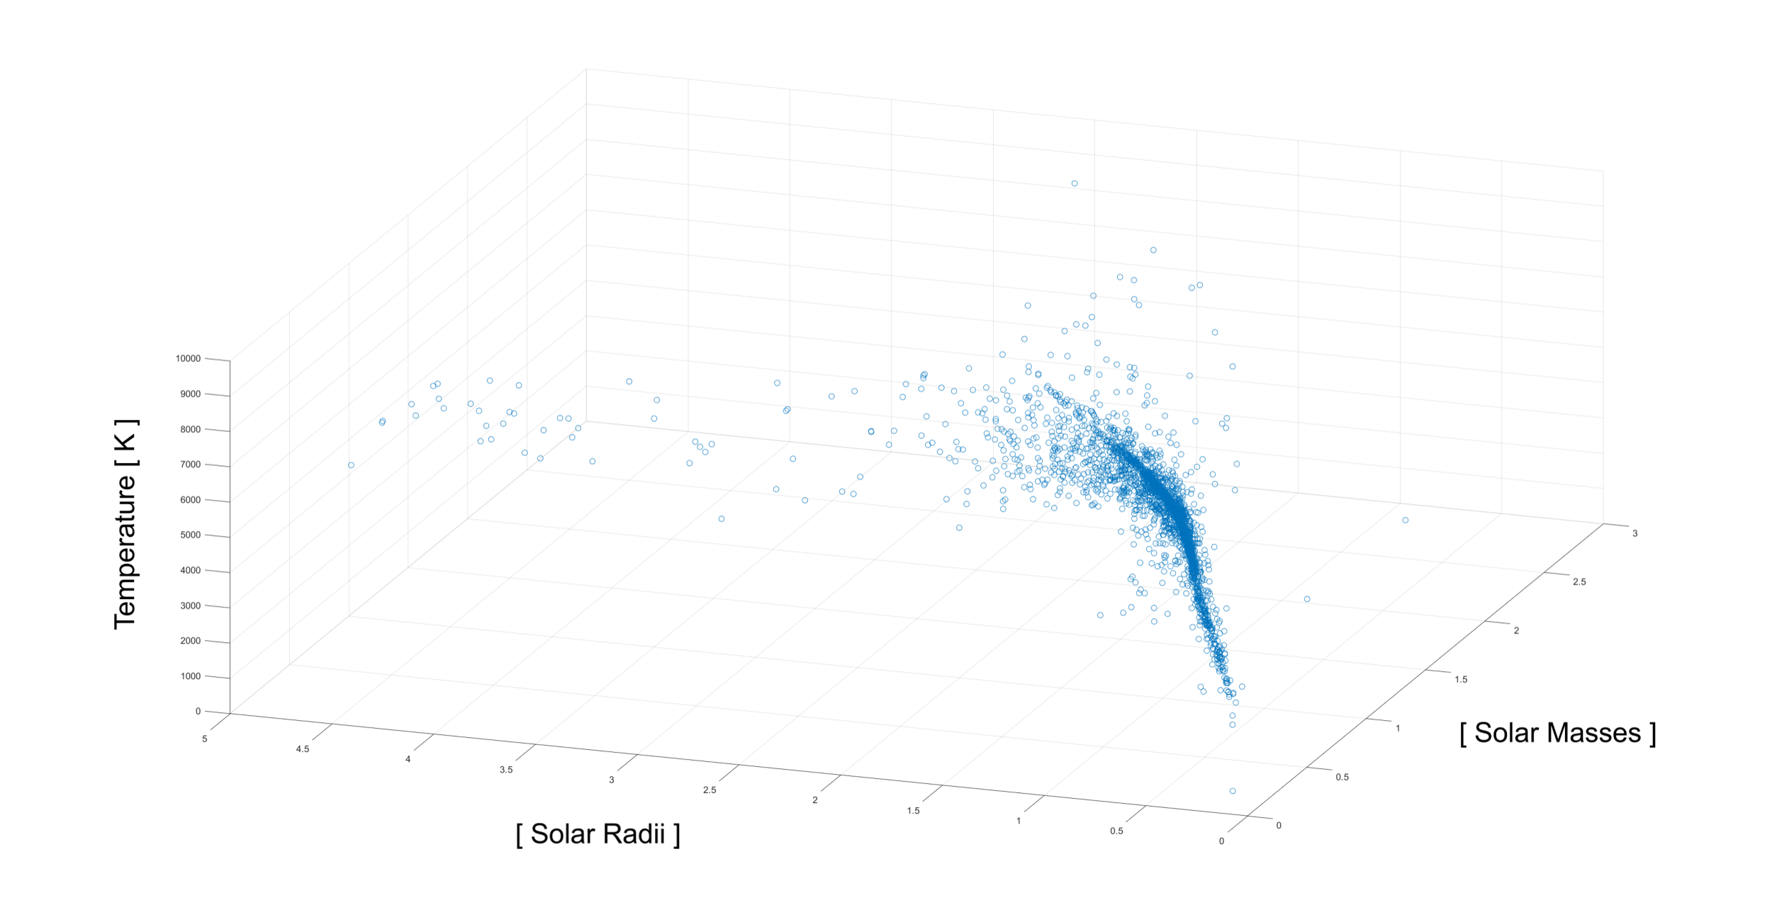

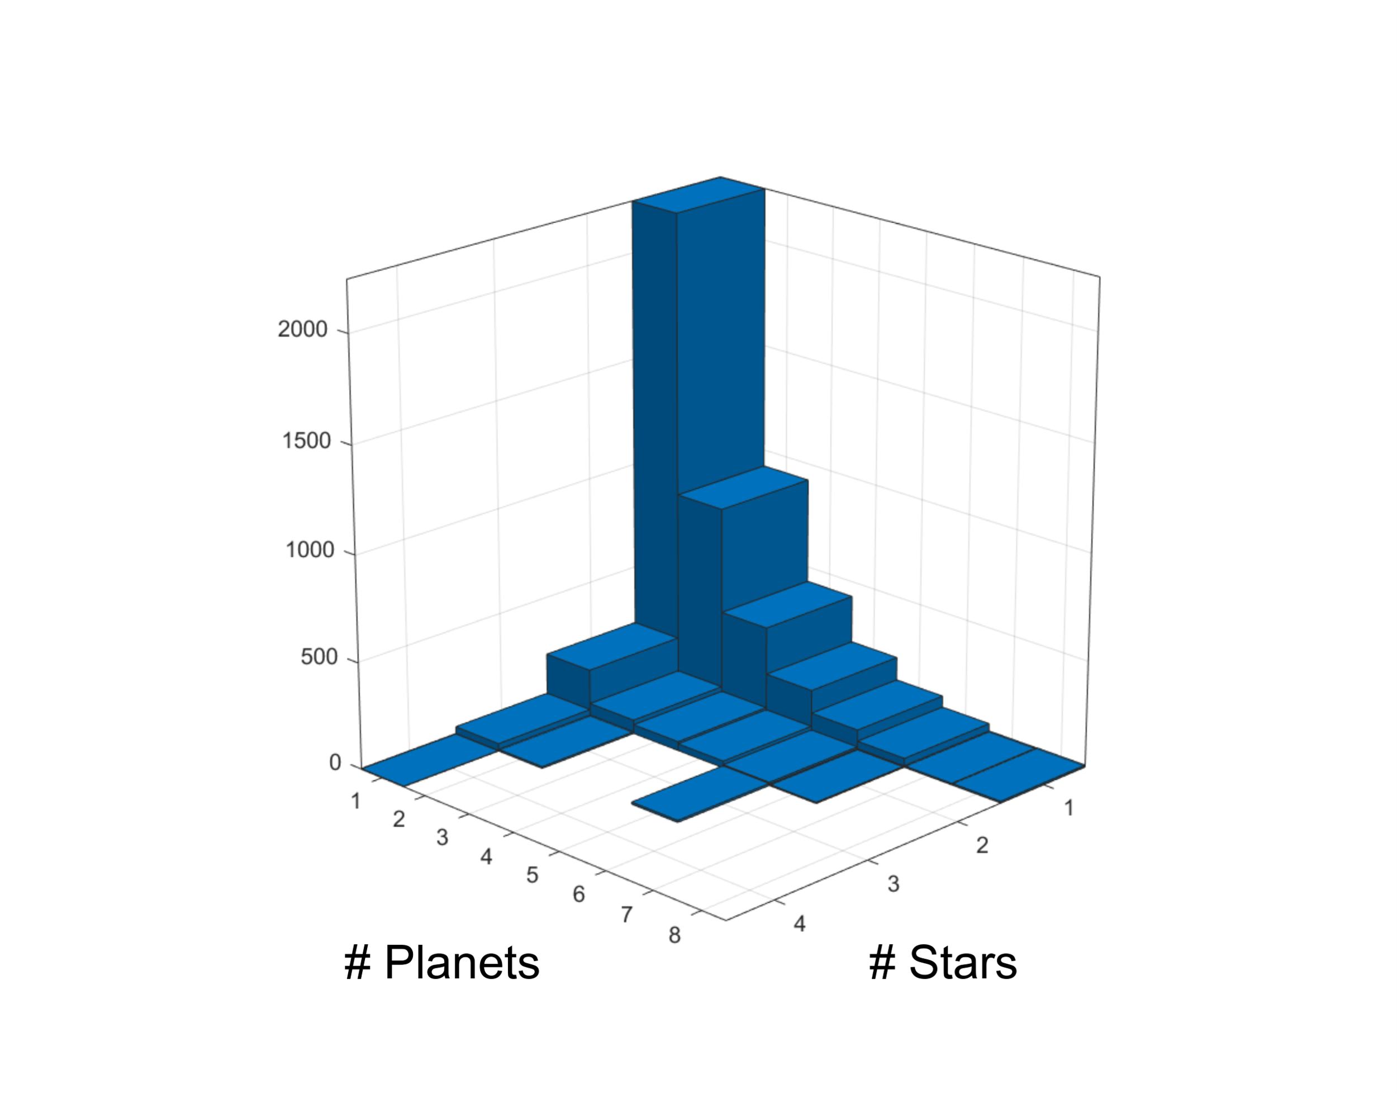

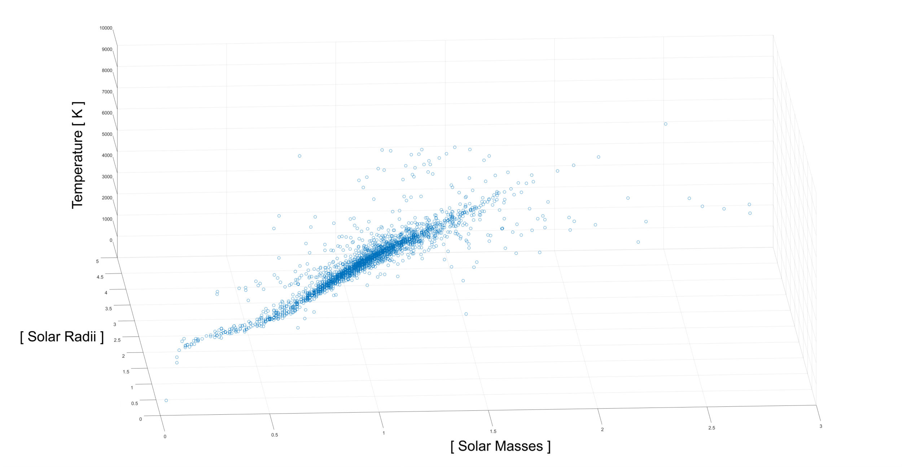

The last three parameters concern the star of the system, its mass, radius, and temperature.

The scatterplot of these three quantities shows a strong correlation, so we tried to find a multiple linear regression model. The model was performing poorly even by removing the outliers and including quadratic and cubic terms for the two predictors mass and radius.

Analyzing the components of planetary systems, as expected, we note that one-star systems are the most common.

However, it is important to note that the number of single-planets systems is clearly due to a strong bias related to the nature of the research and methodology.

It cannot be assumed that there are predominantly single-planet systems in nature.

**Part II: Hypothesis Testing**

Following the review of the fundamental parameters that characterize exoplanets, we want to subject these elements to a study that allows us to deduce a model that can predict their temperature. To this end, we want to support two assertions through hypothesis tests:

1. The average temperatures do not depend on the number of stars of the system
2. Discovery methods generated a strong bias in the data pool

We proceed, therefore, by dividing the temperatures by number of stars into categories.

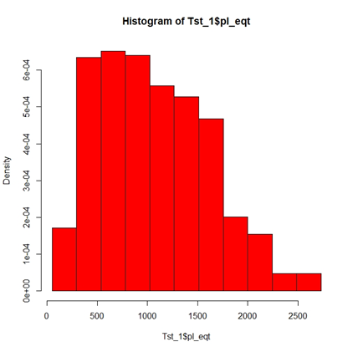

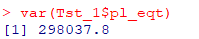Temperatures of planets with a **single** **star**:

**T_st1** 692 data points

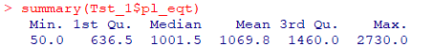**Classes** 1 + log2 (692) = ⌈10.43⌉ = 11

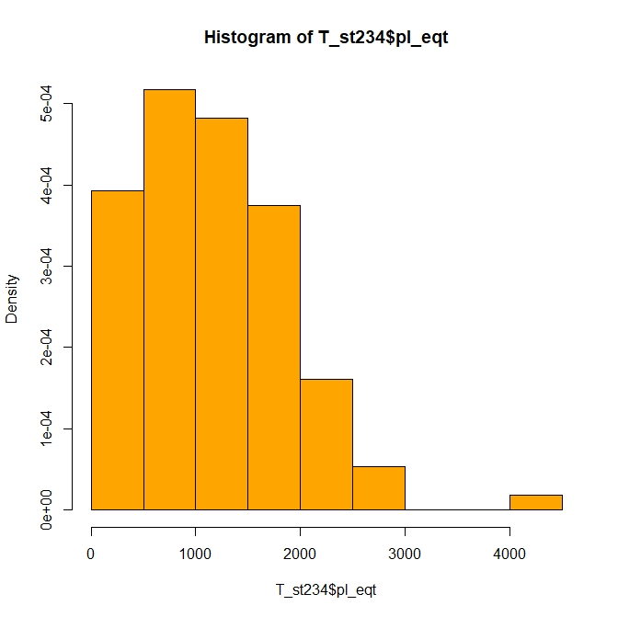

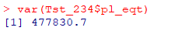Temperatures of planets with **more than two stars**:

**T_st234** 112 data points

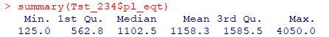**Classes** 1 + log2 (112) = ⌈8.8⌉ = 9

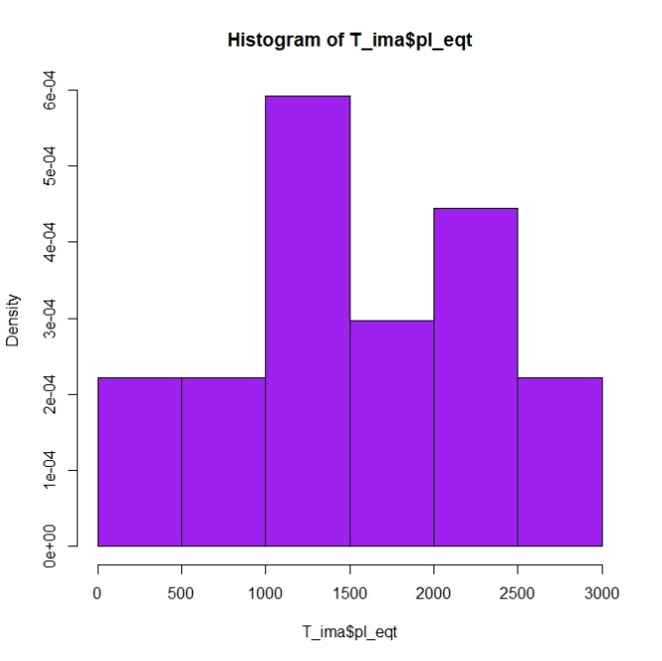We also divide temperatures into categories by method of discovery.

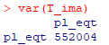

Planetary temperatures measured by **imaging**

**T_ima** 27 data points

**Classes** 1 + log2 (27) = ⌈5.75⌉ = 6

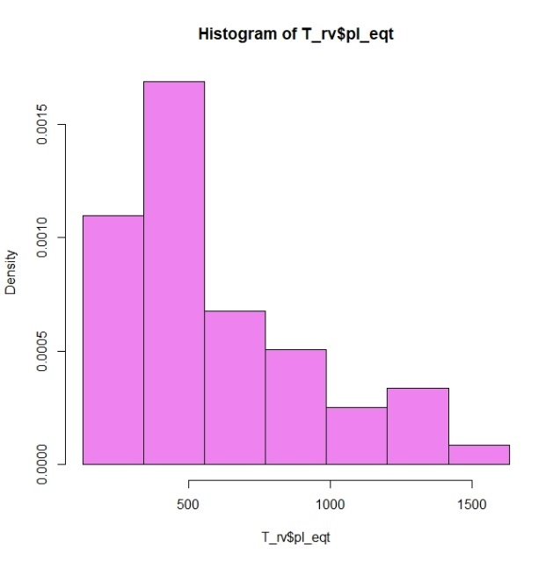

Planetary temperatures measured by **radial velocity**

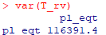**T_ rv** 55 data points

**Classes** 1+ log2 (55) = ⌈6.78⌉ = 7

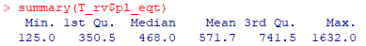

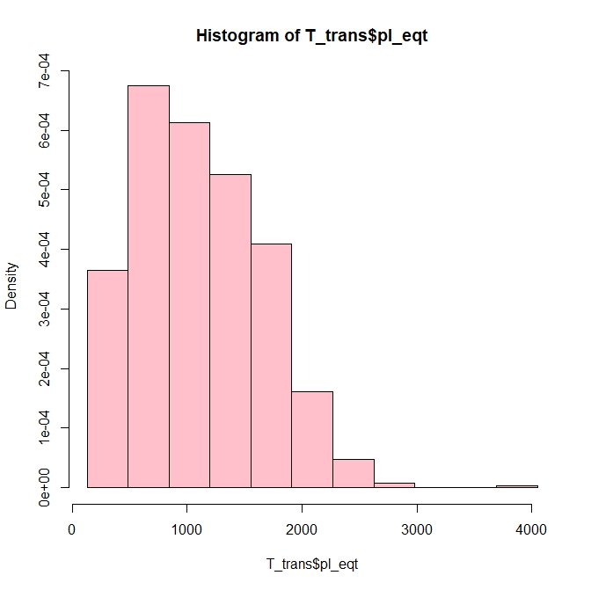

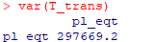Planetary temperatures measured by **transit**

**T_trans** 715 data points

**Classes** 1 + log2 (715) = ⌈10.48⌉ = 11 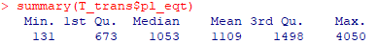

**Normality analysis**

Following the subdivision of temperatures according to the categories described, we proceed by studying the gaussianity of the relative distributions.

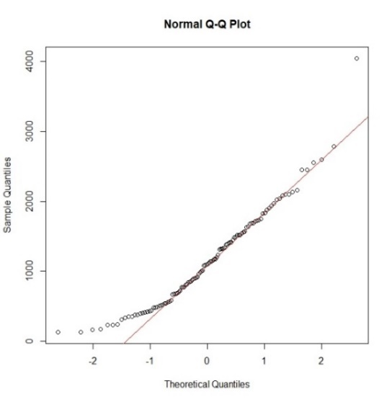 **1 star 2+ stars**

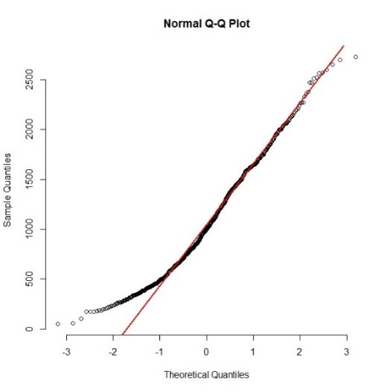

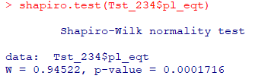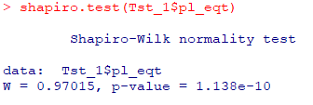

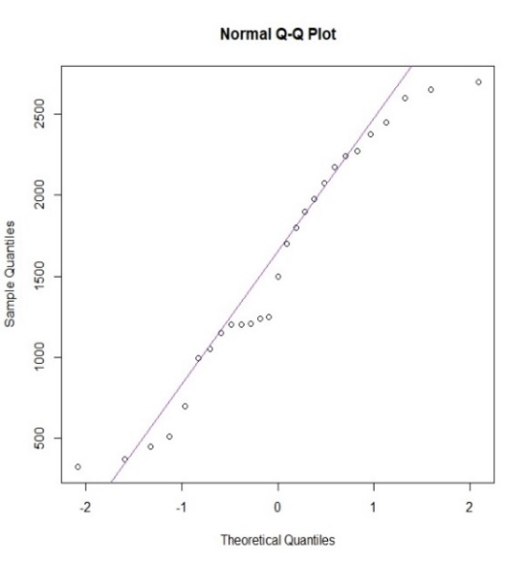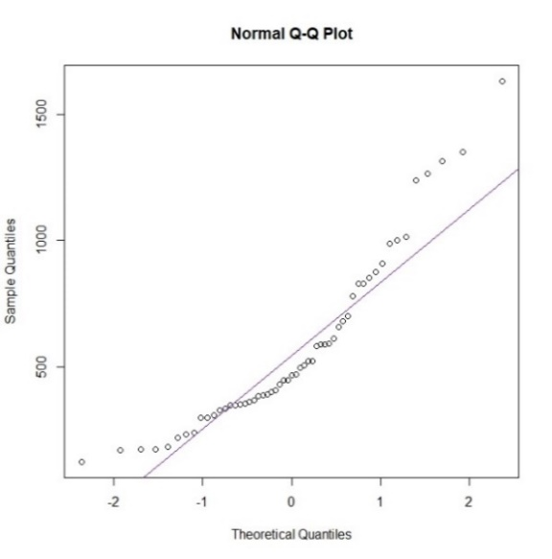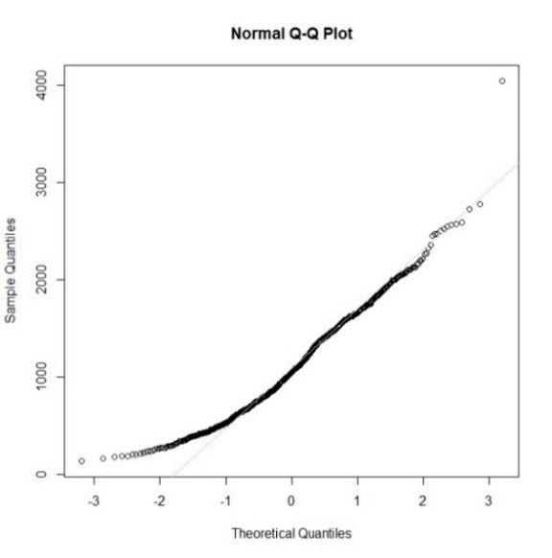 **Radial Velocity Transit Imaging**

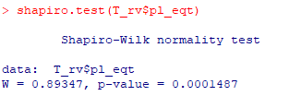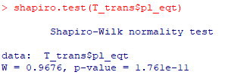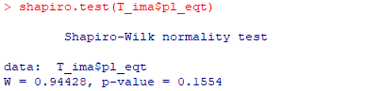

Although the number of samples influenced the power of the Shapiro-Wilks test, making it very susceptible to the slightest variations from the quantile line, the QQ-plots push us to affirm the alternative hypothesis of non-gaussianity. The exception is **T_ima** which, with a low number of n = 27, has a p-value of 0.15554. In this case there is no strong evidence to reject the null hypothesis, so the normality of its distribution is accepted.

For the central limit theorem in the presence of numerous samples ( n > 30 ) we can assume that the sample means have approximately normal distribution.

**Number of stars**

The purpose of the test is to support the idea that the average of temperatures is not correlated with the number of stars belonging to the system. To this end, a bilateral Z-test is performed on two numerous samples.

$$Z_{0}=\frac{\overline{X_{m}}-\overline{Y_{n}}-δ_{0}}{\sqrt{\frac{{\left(S_{x}\right)}^{2}}{m}+\frac{{\left(S_{y}\right)}^{2}}{n}}} con δ_{0}=0$$

**“Are the average temperatures of planets with a single star in their planetary system different from planets with multiple stars?”**

$$H_{0} :µ_{\left(T_{ _}st1\right)}=µ_{\left(T_st234\right)}$$

$$H_{1} :µ_{\left(T_{ _}st1\right)}≠µ_{\left(T_st234\right)}$$

$$RC :\left|Z_{0}\right|>Z_{1-α/2}$$

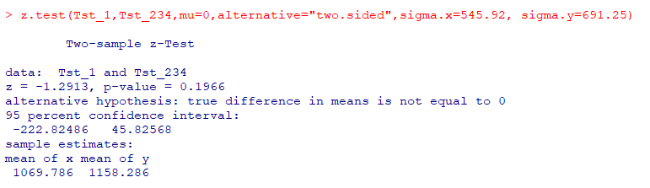

The test has a p-value of 0.1966. There is no strong evidence to reject the null hypothesis. It is concluded that the average temperatures of the planets are not dependent on the number of stars belonging to the system.

**Discovery method**

We now proceed with the definition of a second bilateral Z-test that verifies the difference in mean temperature detected according to the methodology used. The comparison takes place between the methods of Transit and Radial Velocity, on which the TLC is applicable.

**"Do detection methods influence the average temperature detected with a strong bias?"**

**Transit VS Radial Velocity**

$$H_{0} :µ_{\left(T_{ _}rv\right)}=µ_{\left(T_trans\right)}$$

$$H_{1} : µ_{\left(T_{ _}rv\right)}≠µ_{\left(T_trans\right)}$$

$$RC :\left|Z_{0}\right|>Z_{ 1 - α/2}$$

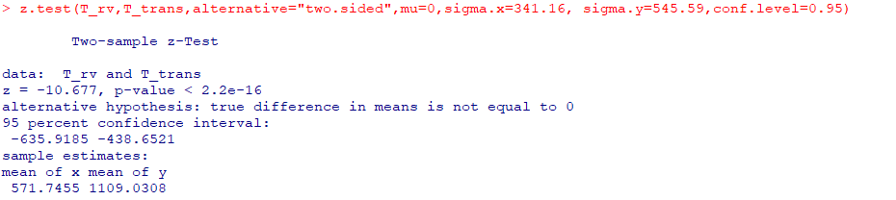

The extremely low p-value allows us to have strong evidence against the null hypothesis. Therefore, the alternative hypothesis is assumed to be true.

**Radial Velocity VS Imaging**

The subsequent Z-test between **Radial Velocity** and **Imaging** assumes the normality of the sample mean of the data taken from the Imaging although it has a rather borderline number n = 27 < 30. This assumption is valid since it has been verified with a Shapiro-Wilks test that its normality is not refutable. The same goes for the unknown variance, which can be estimated with good precision with:

$${S^{2}}_{y}=\frac{\sum_{i=0}^{n}{\left(x_{i}-\overline{x}\right)}}{n-1}$$

$$H_{0} :µ_{\left(T_{ _}rv\right)}=µ_{\left(T_ima\right)}$$

$$H_{1} : µ_{\left(T_{ _}rv\right)}≠µ_{\left(T_ima\right)}$$

$$RC :\left|Z_{0}\right|>Z_{ 1 - α/2}$$

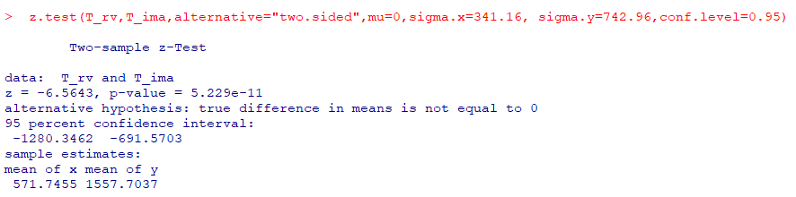

The result obtained, as could already be assumed, has an extremely low p-value, giving strong evidence to reject the null hypothesis and accept that alternative. We can again say that the means are different.

**Transit VS Imaging**

In this last test, all the assumptions made in the previous point are held.

$$H_{0} :µ_{\left(T_{ _}trans\right)}=µ_{\left(T_ima\right)}$$

$$H_{1} : µ_{\left(T_{ _}trans\right)}≠µ_{\left(T_ima\right)}$$

$$RC :\left|Z_{0}\right|>Z_{ 1 - α/2}$$

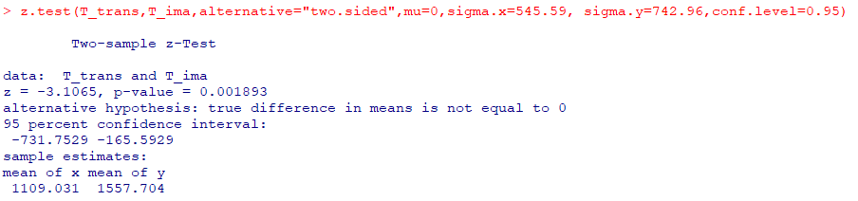

The test has a low p-value. The null hypothesis is rejected, and the alternative is accepted.

In conclusion, it can be said that the average of temperatures varies strongly according to the methods of detection of the planets. We therefore affirm the presence in the pool of a strong bias in favor of the method used, favoring the presence of data relating to the “Transit” discovery method (the most numerous).

**Rover Survival Temperature**

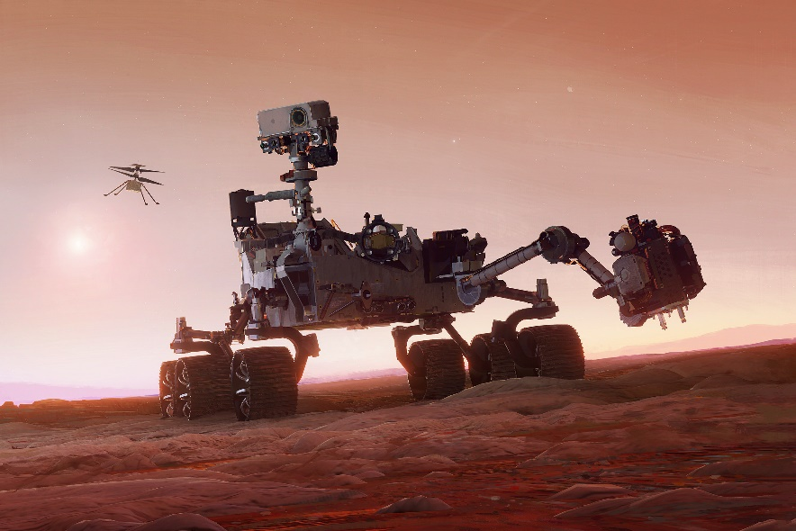

A fundamental role in the study of extraterrestrial planets is played by small albeit sophisticated robots, capable of operating under extreme conditions to provide necessary data to study the universe: **rovers**.

We now want to study the probability that a rover can survive on a desired exoplanet.

To this end, we considered one of the most famous if not the most resistant rovers, capable of withstanding up to extreme temperatures of 1300 °C**: Perseverance**.

Due to the nature of **pl_eqt** (planet’s equilibrium temperature), a parameter in our possession, it is assumed that all the planets are black bodies at constant temperature.

We then proceed by carrying out a sample proportion test. The sample size **n = 804 > 30** allows us to find a precise $\hat{p}$ estimator of the expected value of the Bernoulli variable.

It is assumed that each random variable is independent and identically distributed.

$$p_{i}= \left\{\begin{matrix} 0 \\ 1\end{matrix} \begin{matrix}if { T}_{i}≥1573 K \\ if { T}_{i}<1573 K\end{matrix}\right.$$

**“The probability that Perseverance withstands the planet's temperature is less than 79%”**

$$Z_{0}=\frac{\overline{X_{n}}-p_{0}}{\sqrt{p_{0}\left(1-p_{0}\right)}}\sqrt{n}$$

$$H_{0} :p≥p_{0}=0.79$$

$$H_{1} : p<p_{0}$$

$$RC :\left|Z_{0}\right|<{-Z}_{\left(1-α\right)}$$

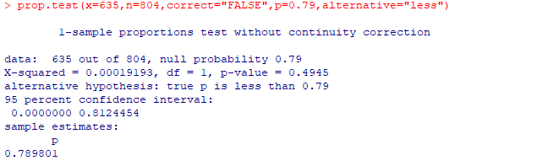

Given the **p-value = 0.49 > 0.05**, there is insufficient evidence to reject the null hypothesis and accept the alternative hypothesis. Therefore, it is concluded that the probability that the rover can survive the temperature of any planet is greater than 79%.

We construct a 95% confidence interval to obtain a range of possible values ​​for $\hat{p}$ using the following formula:

$${IC}_{γ}\left(p\right) : \hat{p} ± z_{\left( 1 + \frac{γ}{2} \right)} \frac{\hat{p} \left(1-\hat{p}\right)}{n}$$

$\hat{p}=\frac{n_{ \left(T<1300\right)}}{n}=0.789801$**, $γ=0.95$**

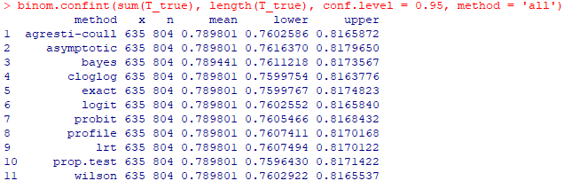

Taking as a reference the result obtained from the prop test, we build the interval:

$$IC_{\left(0.95\right)}: \left( 0.7596430 , 0.8171422 \right)$$

Placed as the center $\hat{p}=0.79$ the interval straddles between the regions supported by the two hypotheses. Precisely the right region $\hat{p}≥0.79$ belongs to the null hypothesis, while $\hat{p}<0.79$ belongs to the region of the alternative hypothesis

**Part III: Multivariable regression**

The goal of our regression will be to determine a model for the prediction of the planet's surface temperature, using predictors based on parameters of the planetary system of interest.

To begin with, all predictors that could have some correlation with the planet's temperature were included, which is why the parameters on the planet's position in the sky were immediately excluded. It will be noted that the request to have a value for each column immediately restricts the number of usable samples, which is always around a hundred.

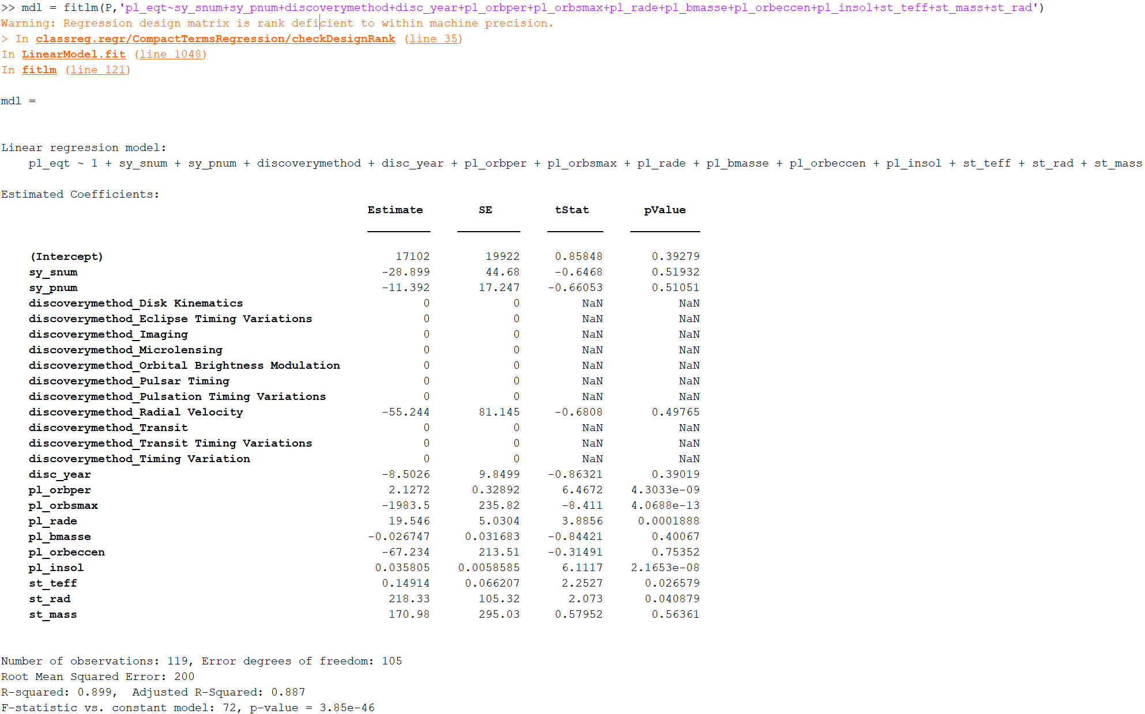

We then proceed to and perform the multiple linear fit and analyze the results:

The first model that includes the totality of predictors has obvious problems, all categorical predictors regarding the discovery method are too few to give significant results and all their values are N.A. We note, however, that the low value of the F statistic assures us of the good overall significance of the model. We then proceed to remove the categorical predictor "**disc_year**" and perform the fit again. The second model is improved but we note that the p-values for many predictors are very high. The p-value provided by MATLAB are in fact related to this test

$$H_{0} : β_{k}=0$$

$$H_{1} : β_{k}≠0$$

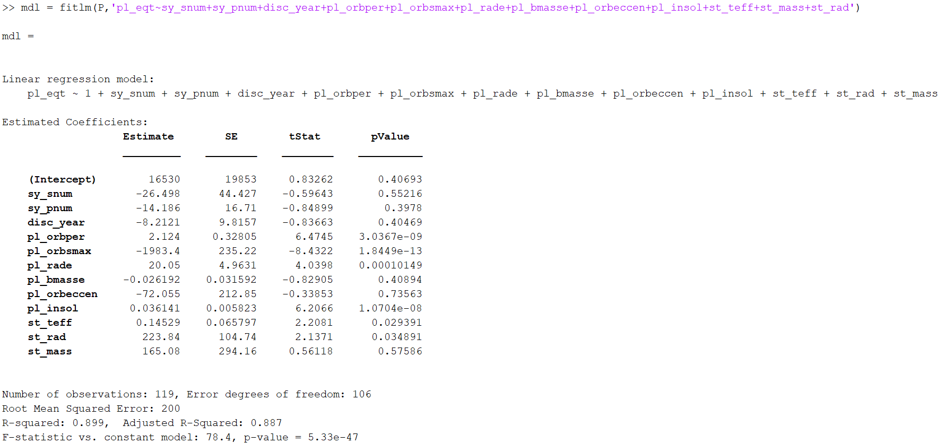

We then proceed iteratively to remove the predictor with the highest p-value (> 10%), the result is a series of predictors with very low p-values (< 10-5).

Remarkably, with this process we also removed the predictor referred to the number of stars, confirming what in the hypothesis test seemed likely.

The only high p-value is that of the intercept, in fact we see that a test at the significance level $α=0.05$ would lead us to reject $H_{0} : β_{0}=0$ for very little, not being satisfied with this we leave open the possibility that the intercept is nothing.

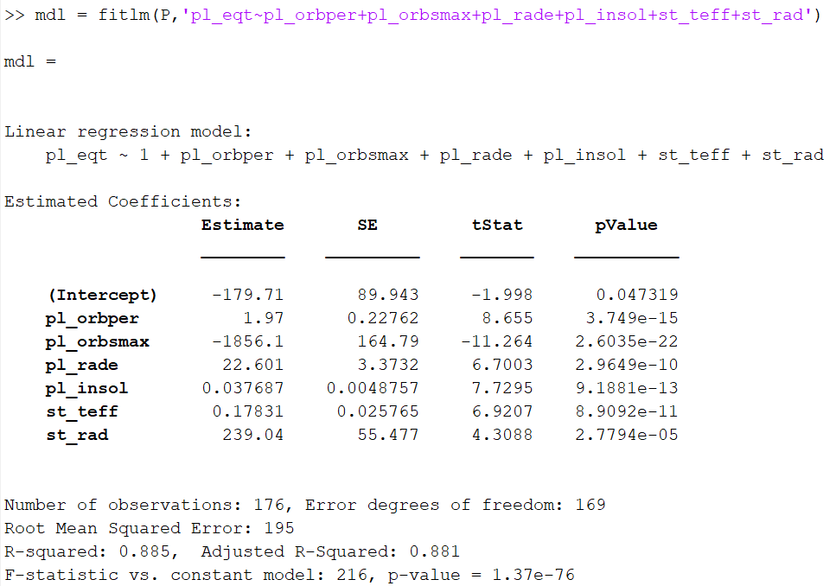

The coefficient of determination has not changed much from the first model and at the moment it stands at a good value of $R^{2}=0.885$ the number of predictors is very low compared to the number of observations, so we are sure not to have exceeded into overfitting, this is confirmed by the always good value of

$$R_{adj}^{2}=0.881$$

So, let's analyze the distribution of residues:

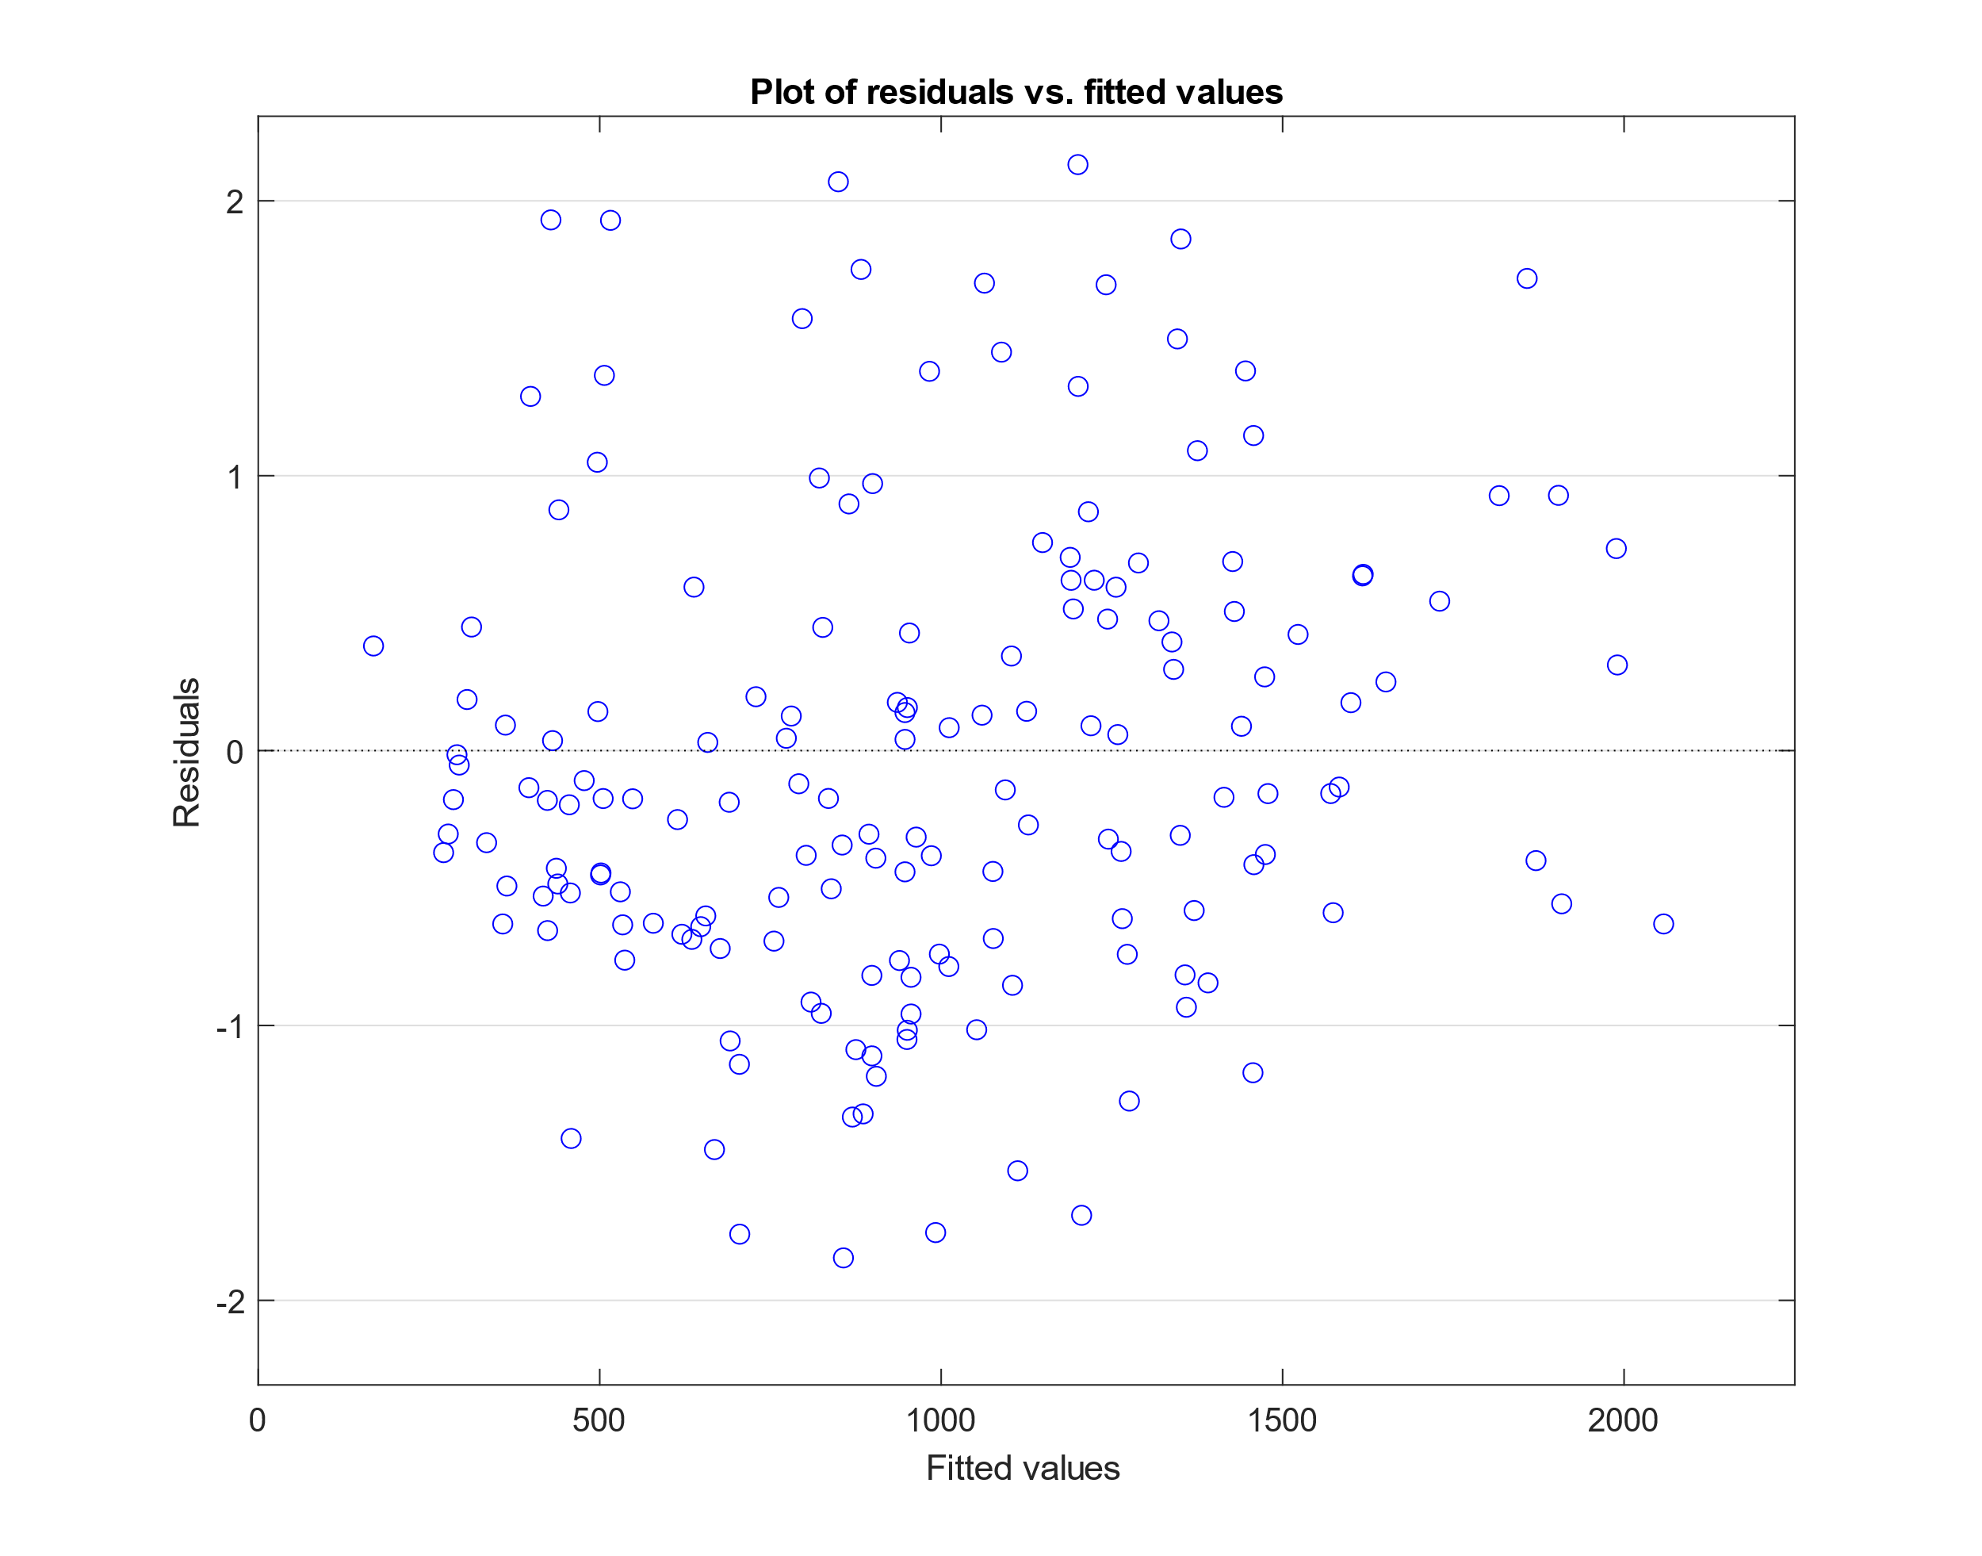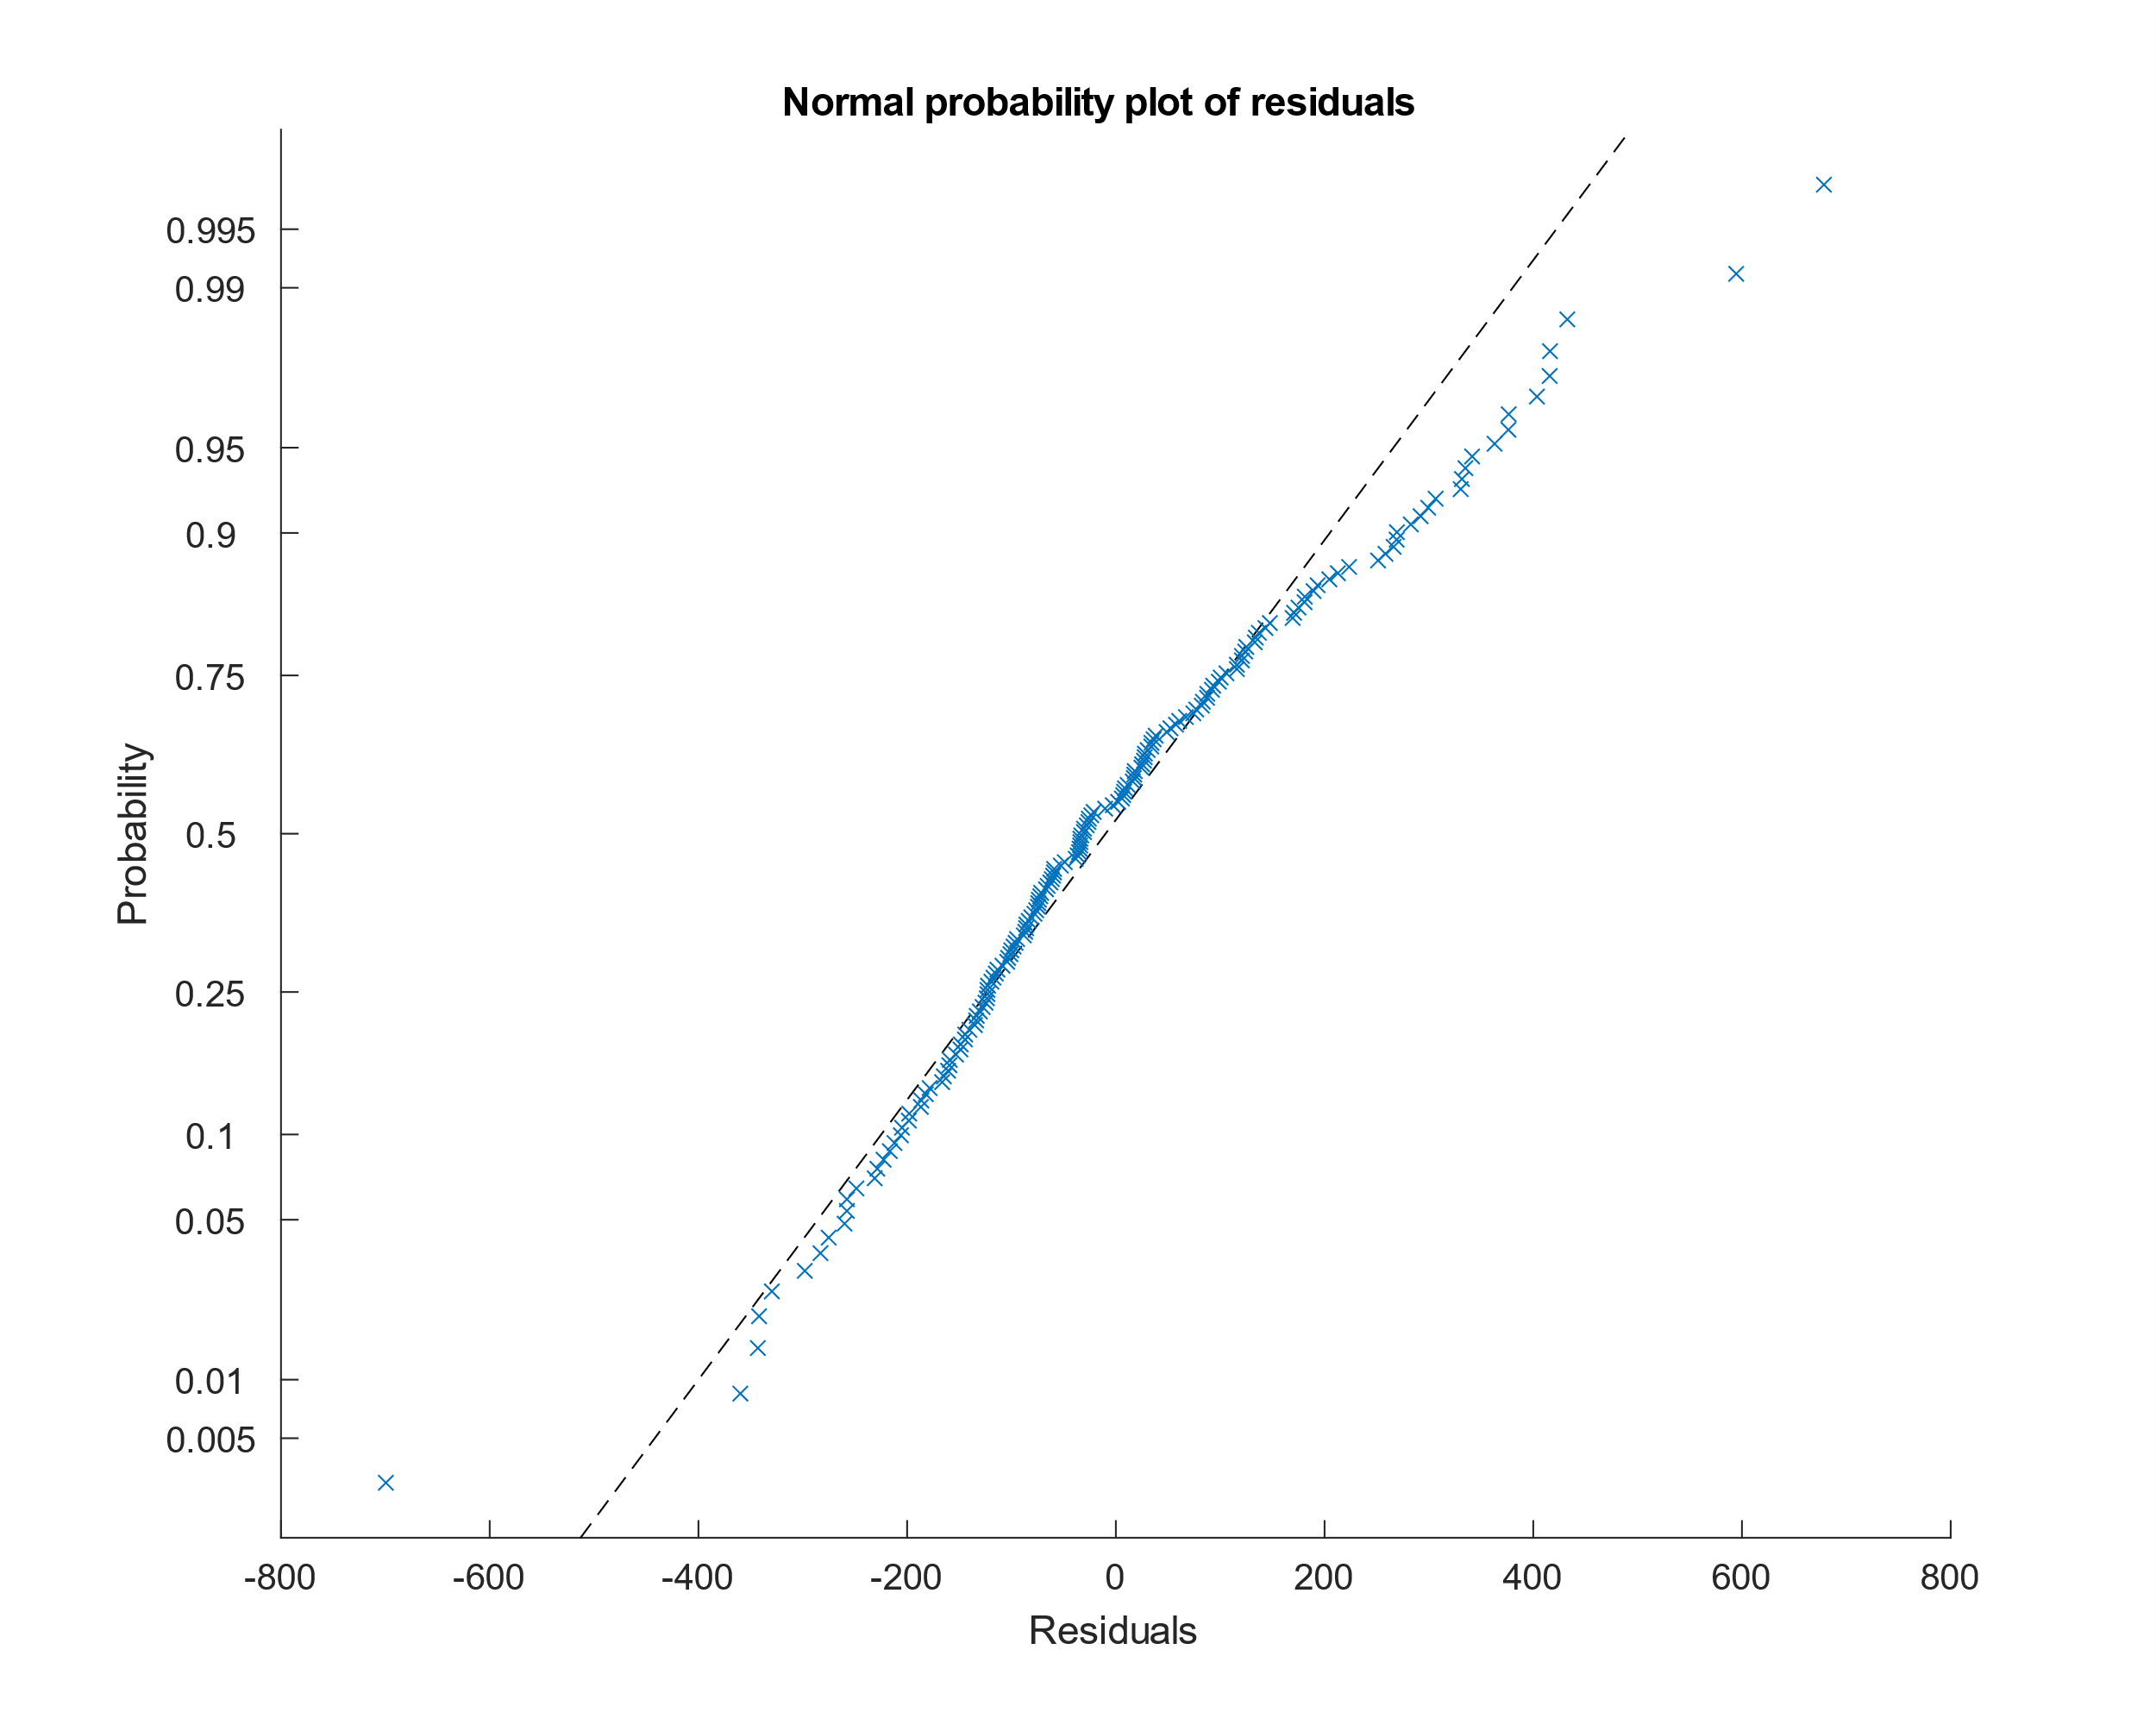

Although the graph of the residuals on fitted values shows a homoskedasticity at the limit of the acceptable, the QQ-plot of the residuals forces us to review the model.

We therefore propose other models with squared predictors, most of which contribute to an increase in the coefficient of determination but none of them solve the problem of heteroskedasticity of the data

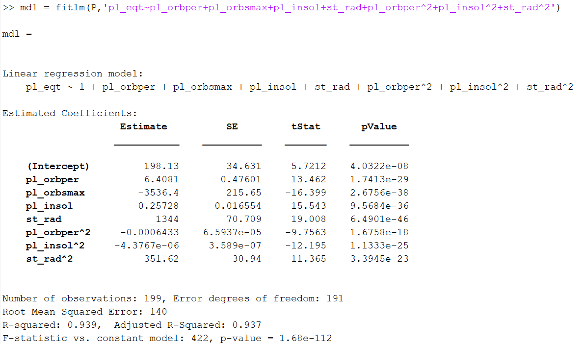

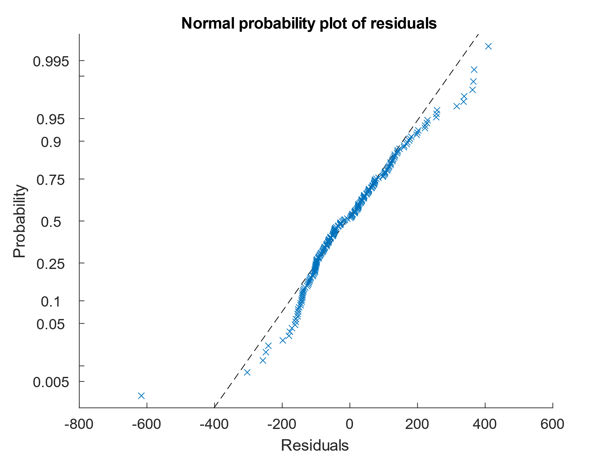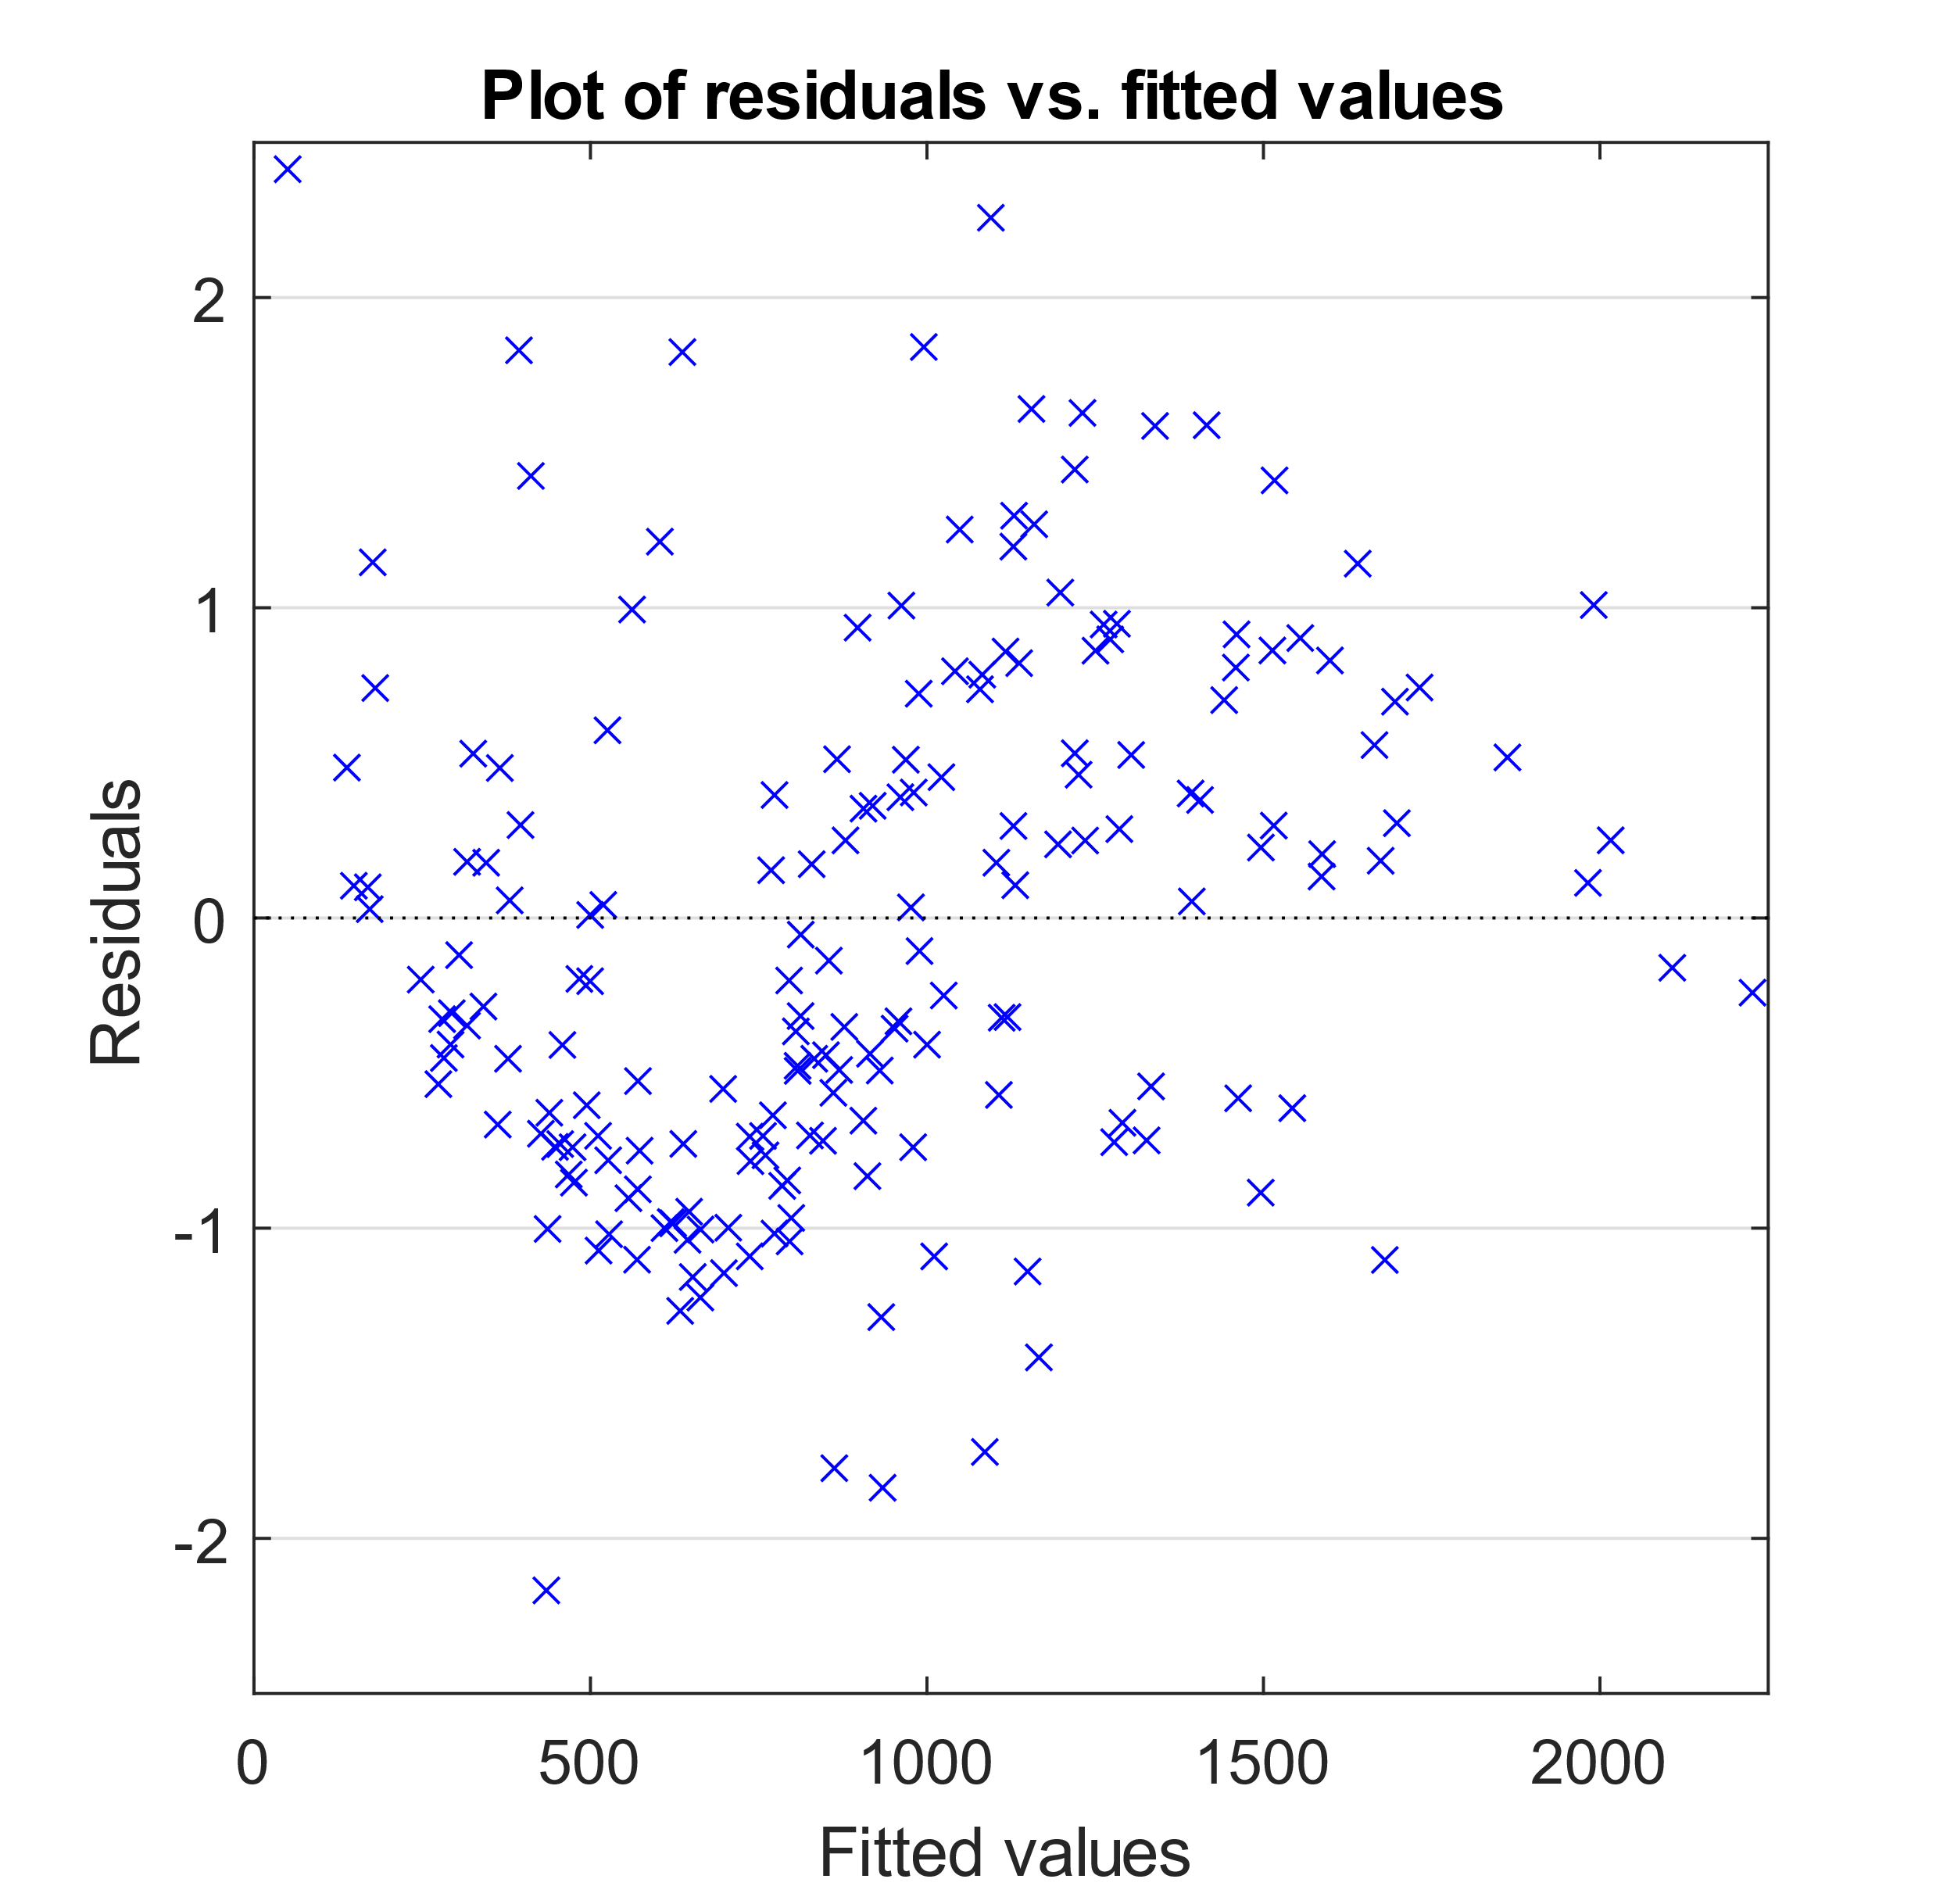

This model was obtained by including all predictors and their squares and proceeding as before with the removal of the least significant predictors in order of decreasing p-values.

The value of R2of this model has increased, settling at $R^{2}=0.939$ nevertheless the adherence of the data to the quantiles in the QQ-plot has definitely worsened and also the residual plot shows a strongly heteroskedastic trend, with a hint of parable.

Again, we note that the model's coefficient of determination is very good, but the residuals are distinctly heteroskedastic.

In an attempt to find a model that respected the assumption of homoskedasticity of the residues, there were several models that did not give the desired results, models with simple interactions, with square or cubic interactions, with the logarithms or inverses of some predictors. These gave all worse results than those presented above, so we are obliged to consider the first model, the one with the most homoskedastic residues. the final one.

We emphasize that the model is far from perfect, however we do not have all the parameters that could affect the temperature, such as the composition of the planet or the composition of the star, so we believe the model is quite satisfactory for our purposes.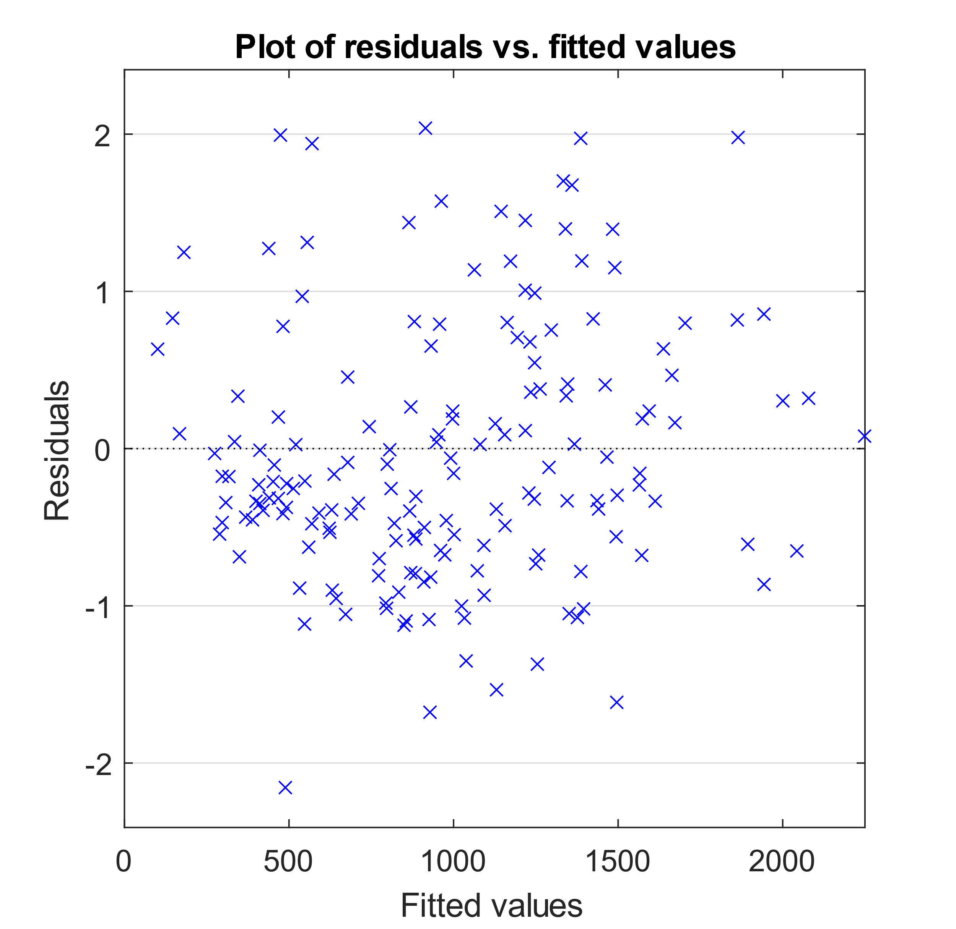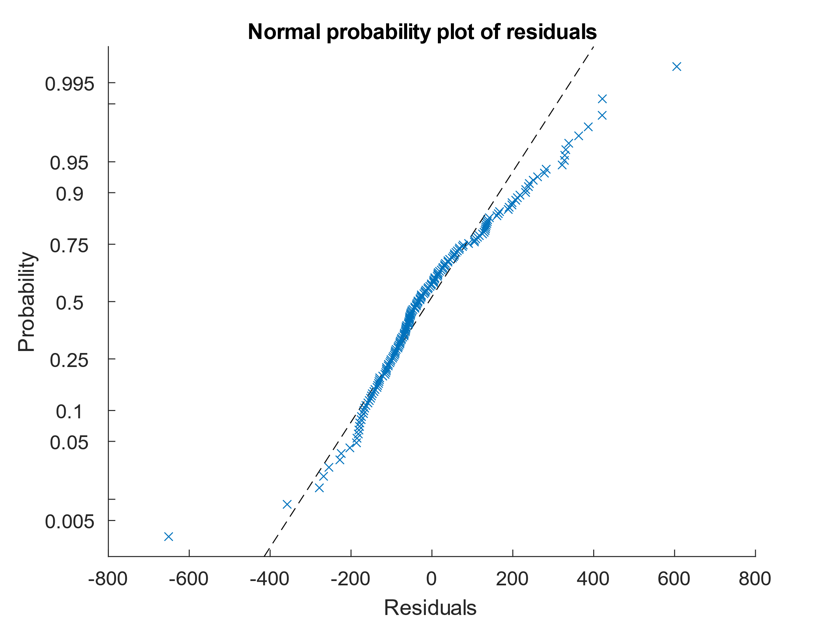

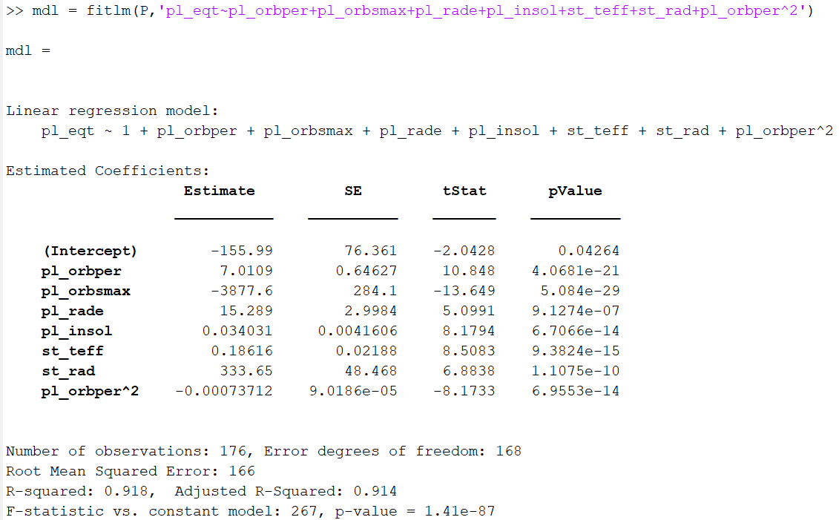

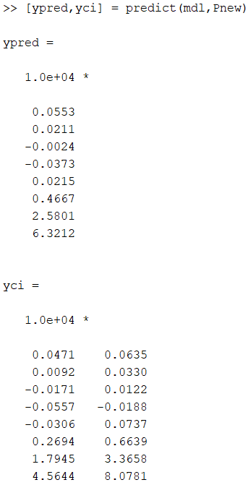

To test the model, we try to make predictions, in particular we try to predict the temperature of the planets of the solar system based on their parameters using the first model.

MATLAB returns both point estimates for temperatures and 95% confidence intervals. The outputs are ordered in increasing order by the distance from the Sun. The results are nothing short of terrible, the only planet whose temperature falls within the confidence intervals is Mercury, whose temperature is:

$$471K<600K<635K$$

for all the other planets the confidence intervals are completely wrong, even giving negative results (remember that temperatures are given in Kelvin).

We can hypothesize that the low temperatures of the solar system do not agree with the pool of very hot planets that we used to create the regression model and that therefore our model is not able to accurately predict such atypical members with respect to our dataset.

**Conclusions**



The dataset chosen, albeit very large, allows a limited number of strong deductions and the large bias presented at the beginning leaves no room for comparisons with the only planets we know for direct measurements.

The subject of exoplanetary habitability is extremely complex and is much less prone to a statistical analysis than what was initially thought. Nevertheless, the results obtained could support an astronomical study, without a statistical analysis of this type in fact the intrinsic bias to the discovery of exoplanets is not evident and the scientist placed in front of this dataset could draw erroneous conclusions on the actual population of exoplanets in the universe.

**Additional Resources**

**Datasets:**

* NASA Exoplanet Archive
* NASA Planetary Fact Sheet
* PHL’s Habitable Exoplanets Catalogue
* PHL's Exoplanets Catalog
* PHL’s Data of Potentially Habitable Worlds

**Used Softwares:**

* MATLAB
* R Studio

**Acknowledgements:**

* Statistical properties of exoplanets-Planets and Astrobiology (2018-2019) G. Vladilo
* Properties of Extrasolar Planets ASTR 241.
* Direct Imaging, Las Cumbres Observatory.
* Surface Temperatures of Exoplanets (2015) Weisfeiler, Turcotte, Kellogg.
* The Masses and Orbital Dynamics of Exoplanets (2016) Weiss, Marcy.
* Finding the Mass of an Exoplanet - Joey Chatelain, Jeremy Jones, and Ryan Sketch
* Calculating Exoplanet Properties, Simon Fraser University
* Studio delle condizioni fisiche favorevoli alla fotosintesi per esopianeti nella zona abitabile (2019-2020) Riccardo Maria Ienco
* HD10647 and the Distribution of Exoplanet Properties with Semi-major Axis (2004) J.P.Beaulieu, A. Lecavelierdes Etangs, C. Terquem
* The sub-Jovian desert of exoplanets: parameter dependent boundaries and implications on planet formation (2019) Gyula M. Szabó, Szilárd Kálmán
* Beyond the exoplanet mass-radius relation (2019) Ulmer-Moll, Santos, Figueira, Brinchmann, Faria.
* Exoplanet orbital eccentricity: Multiplicity relation and the Solar System (2015) Mary Anne Limbach and Edwin L. Turner
* Missione Spaziale Kepler - Studio statistico sulla classificazione degli esopianeti (2021) F. Abbate, M. Montanari, G. Rigolizzo